EMEA/APAC Market

Quick Guide

ADF P100, ADF P300

REV.1 2017-04-10

Copyright COMSYS AB 2008 – 2017

This document is the sole property of Comsys AB and may not without the written consent of the owner be copied, transmitted or otherwise disclosed to any third party

Comsys AB

Fältspatvägen 4

224 78 Lund

Sweden

T +46 10 209 68 00

F +46 10 209 68 05

Sales

Contact [sales@comsys.se](mailto:sales@comsys.se) or call +46 10 209 68 00 and select option 1

Service/Support

Contact [servicesupport@comsys.se](mailto:servicesupport@comsys.se) or call +46 10 209 68 00 and select option 2

General Inquiries

Contact [info@comsys.se](mailto:info@comsys.se)

Related information

|  |  |
| --- | --- |
| Document | Doc No |
| ADF P300 Hardware Manual | 1199 171 |
| ADF P100 Hardware Manual | 1199 273 |
| ADF P100/P300 User Manual | 1199 172 |

Specifications are subject to change without notice.

This document is the sole property of Comsys AB and may not without the written consent of the owner be copied, transmitted or otherwise disclosed to any third party.

# Safety Notes & Applicable Products

Read these instructions carefully and look at the equipment to become familiar with the product before trying to install, operate or maintain it. The following special messages may appear throughout this manual to warn of potential hazards or to call attention to that which clarifies or simplifies a procedure:

|  |  |  |
| --- | --- | --- |
| 🛆 | **ATTENTION:** Identifies information about practices or circumstances that can lead to personal injury or loss of life, property damage, or economic loss. | |
| NOTE | | Provides additional information to clarify or simplify a procedure. |

|  |  |
| --- | --- |
| 🛆 | **ATTENTION:** Only qualified electrical personnel familiar with the construction and operation of this equipment and the hazards involved should install, adjust, operate, or service this equipment. Read and understand this manual and other applicable manuals in their entirety before proceeding. Failure to observe this precaution could result in severe bodily injury or loss of life.  **ATTENTION:** The product contains DC bus capacitors which retain hazardous voltages in excess of 1000 V after input power has been disconnected. After disconnecting input power, wait at least sixty (60) minutes for the DC bus capacitors to discharge and then check the voltage with a voltmeter to ensure the DC bus capacitors are discharged before touching any internal components. Failure to observe this precaution could result in severe bodily injury or loss of life.  **ATTENTION:** This product may have been modified from factory in order for the auxiliary power to be supplied externally. After disconnecting main fuses, the external auxiliary power must also be disconnected.  **ATTENTION:** Before manipulating current transformers, make sure that the secondary is short-circuited. Never open the secondary of a loaded current transformer. You must always wear isolating gloves and eye-protection when working on electrical installations. Also make sure that all local safety regulations are fulfilled.  **ATTENTION:** Only qualified personnel or other trained personnel who understand the potential hazards involved may make service, updates, troubleshooting, repair or similar work to the product. Any such activities not made corrects may result in uncontrolled operation. Failure to observe this precaution could result in damage to equipment and bodily injury. Although reasonable care has been taken to provide accurate and authoritative information in this document, no responsibility is assumed by **Comsys** for any consequences arising out of the use of this material. |

This manual applies to products listed in the table below:

|  |  |  |  |
| --- | --- | --- | --- |
| Product line | Models | Current rating | Voltage |
| ADF P300  Air cooled,  3 wire | ADF P300-120/480 | 120 ARMS | 208 – 480 V |
| ADF P300-240/480 | 240 ARMS |
| ADF P300-360/480 | 360 ARMS |
| ADF P300-90/690 | 90 ARMS | 480 – 690 V |
| ADF P300-180/690 | 180 ARMS |
| ADF P300-270/690 | 270 ARMS |
| ADF P300  UL/cUL version  Air cooled,  3 wire | ADF P300-110/480-UL | 110 ARMS | 208 – 480 V |
| ADF P300-220/480-UL | 220 ARMS |
| ADF P300-330/480-UL | 330 ARMS |
| ADF P300-90/600-UL | 90 ARMS | 480 – 600 V |
| ADF P300-180/600-UL | 180 ARMS |
| ADF P300-270/600-UL | 270 ARMS |
| ADF P100,  Air cooled,  3 wire | ADF P100-70/480 | 70 ARMS | 208 – 480 V |
| ADF P100-100/480 | 100 ARMS |
| ADF P100-130/480 | 130 ARMS |
| ADF P100N-100/415 | 100 ph. / 300 N ARMS | 380 – 415 V |
| ADF P100-90/690 | 90 ARMS | 480 – 690 V |

## Standards: IEC/CE versions

This product is CE compliant, which implies that is in conformity with the European Community low voltage directives 72/23/EEC and 93/68/EEC and it bears the CE label.

The following standards apply to IEC/CE systems:

|  |  |
| --- | --- |
| Standards | |
| Electromagnetic compatibility | EN 61000-6-2, EN 61000-6-4 |
| Electrical design and safety | EN 50178 / VDE0160 |
| Protection class | IP20 according to IEC 529 (ADF P300)  IP54 according to IEC 529 (ADF P300W) |
| Approval marking | 72/23/EEC, 93/68/EEC CE-mark |

## Standards: UL/cUL versions

The UL/cUL versions, art no 400 083, 400 084, 400 085, 400 086, 400 087, 400 088 are approved according to UL/CSA standards.

|  |  |
| --- | --- |
| Standards | |
| Electrical design and safety | UL508/CSA22.2 |

File no NMTR.E357863.

## How to Use this Manual

The following manual is a quick guide for reference purposes only. For details in full operation of the system, please study the related main documentation, mentioned on page 2.

## Storage Condition

During storage of the unit, the unit should be kept within the following conditions. The conditions are acceptable only when the unit is kept in its shipping packaging.

|  |  |
| --- | --- |
| Maximum storage conditions (in protective shipment package) | |
| Temperature | -25 °C to 70 °C (-13 °F to 158 °F) |
| Relative humidity | Less than 95 %, non-condensing |
| Environmental conditions | Chemical class 3C3  Mechanical class 3S3 |

Long term storage conditions.

|  |  |
| --- | --- |
| Maximum storage conditions (in protective shipment package) | |
| Temperature | -25 °C to 35 °C (-13 °F to 158 °F) |
| Relative humidity | Less than 75 %, non-condensing |
| Environmental conditions | Chemical class 3C3  Mechanical class 3S3 |

## Transport conditions

During transport of the unit, the unit should be kept within the following conditions. The conditions are acceptable only when the unit is kept in its shipping packaging.

|  |  |
| --- | --- |
| Maximum transport conditions (in protective shipment package) | |
| Temperature | -25 °C to 70 °C (-13 °F to 158 °F) |
| Relative humidity | Less than 95 %, non-condensing |
| Environmental conditions | Chemical class 3C3  Mechanical class 3S3 |

### ADF P100 Unpacking & Handling

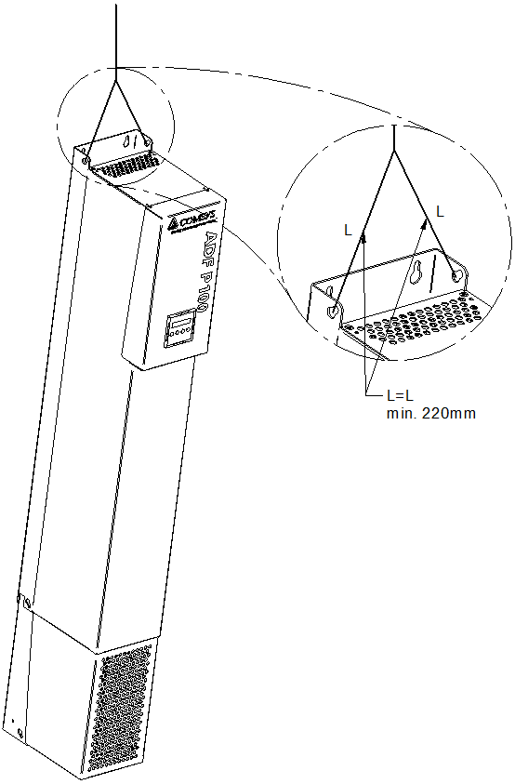Upon reception of the Active Filter, visually inspect that the packaging is in good condition. Verify that all items are present in the package:

* This guide (1199 394)
* ADF P100 Hardware Manual (1199 273)
* ADF P100/P300 User Manual (1199 172)

|  |  |
| --- | --- |
| 🛆 | **ATTENTION:** Before unpacking and installation the Active Filter please read through the following pages THOROUGHLY to make sure that it’s handled in the right way. The unit is heavy and weighs up to 120 kilograms / 265 lbs. |

* Make sure all covers are on the system
* The crated system can be lifted using cranes, forklifts etc.
* The Active Filter may only be lifted in the lifting ears on top of the Active Filter. Also the length of the straps must exceed 220mm and be of the same length according to the figure to the right.

### ADF P300 Unpacking & Handling

Each Active Filter is delivered in packaging suitable for transportation. Upon reception of the Active Filter, visually inspect that the packaging is in good condition. Verify that all items are present in the package:

* This manual (1 199 171)
* The ADF P100/P300 User Manual (1 199 172)
* Bag with distances, screws and cabinet key
* External water hoses (only ADF P300W)
* 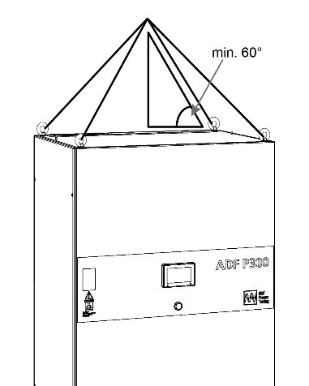V4 and V5 valve in a box (only ADF P300W)

If the Active Filter is to be moved when not in its protective packaging please do it according to this document.

* Always handle the Active Filter with care since it consists of sensitive power electronics.
* The Active Filter may only be lifted in the lifting lugs on top of the Active Filter. Also the angle between the lifting wire and the top of the Active Filter must be minimum 60 degrees according to the figure on right. Please note that roof should not be raised until commissioning and start-up of the system.
* Always keep the door closed on the cabinet, this to keep out dust and other particles that may harm the system.
* Keep roof on without distances
* Keep plastic film over filter inlets on cabinets front until commissioning
* 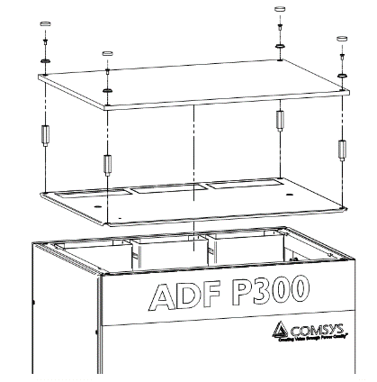Keep plastic cover from wooden box on

Prio to starting up the filter, the roof must be adjusted accordingly:

* **Remove plastic cover:** Remove the plastic cover (if kept from protective packaging) that is covering the whole cabinet.
* **Remove plastic film from cabinet doors:** The plastic film placed at the front over the filter intake has to be removed before starting up the system to make sure that the system gets sufficient amount of air.
* **Raise the roof:** Loosen the four lifting lugs and remove the outer roof. Install the inner roof in its place and make sure to align the cut out holes with the air channels from the power modules. Install the supplied standoff screws in each corner on top of the cabinet and place the outer roof on top of them. Install the supplied M6 screws through a plastic washer in each corner to secure the outer roof in place. Finally install the protective plastic cap on top of each screw.

### ADF P100/P300 Environmental Data

The following table details the allowed environmental operating conditions.

|  |  |
| --- | --- |
| Maximum operating environmental conditions | |
| Temperature | 0 °C to 40 °C with no derating, 40 °C to 50 °C with derating |
| Relative humidity | Less than 95 %, non-condensing |
| Altitude | 1000 m (3300 ft). Derating may be required at higher altitude. |
| Environmental conditions | Chemical class 3C2. Mechanical class 3S2 |

The following table details the needed air flow. The products must be placed in a well ventilated area with no conductive dust.

|  |  |  |
| --- | --- | --- |
| Model | Maximum air flow | Maximum losses |
| ADF P100 (all models), ADF P300-110/480, ADF P300-120/480, ADF P300-90/6x0 | 600 m3/h | <2969W (depending on model and load conditions) |
| ADF P300-220/480, ADF P300-240/480, ADF P300-180/6x0 | 1200 m3/h | <5813W (depending on model and load conditions) |
| ADF P300-330/480, ADF P300-360/480,  ADF P300-270/6x0 | 1800 m3/h | <8657W (depending on model and load conditions) |

### ADF P100/P300 Connection

In both systems, use only copper cable for connection. The figure below shows the terminals on both systems; bottom view of P100 to the left, front view of P300 (with door open) to the right. The Active Filter has three main connector terminals, X10 for the power interface and X12 for CT and X11 for external user functionality signals as seen in Figure 5. They are located at the bottom of the unit.

|  |  |
| --- | --- |
|  |  |

Only Cu cable is approved for the power connection (P300, 12 – 14 Nm, max 300mm2; P100, 15 – 20 Nm, max 95mm2). The below figure shows the principle of current measurement connection. For most applications, closed-loop connection should be used.

|  |  |
| --- | --- |
|  |  |
| Closed loop | Open Loop |

### First start

Before the system can be taken into operation the commissioning procedure will have to be completed. The first step is to verify the installation and make sure that everything is connected properly. Then using a PC connected to the ADF, the *System setup* can be performed. This is where all the system and installation specific settings are configured. After the *System setup* has been completed, *Diagnostics mode* will be entered. Here, an extensive suite of automated diagnostic tests will be run in order to verify the entered settings as well as the installation. If errors are detected, it is required that they are corrected before the system can enter *Normal operation mode*. The figure below illustrates the operating states during setup, diagnostics and normal operation.

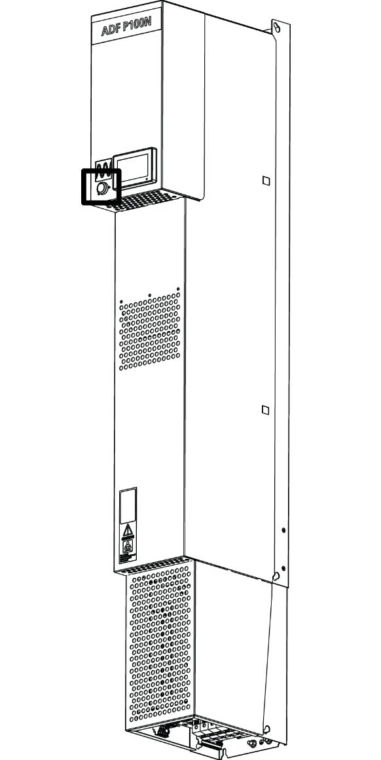

To enter *System setup mode* after power up, simply start up the system. To power the system on from a turned off state, press the PIB once (short press). To power the system off, press and hold the PIB button for around 3 seconds, then release when the button has gone blank. The system is now powered off. The status of the LED gives information of the system; see table below.

|  |  |
| --- | --- |
| PIB LED color | Indication |
| Blank | The system is powered off. Press PIB once to power on the system. |
| Solid yellow | In standby waiting for start condition. Press PIB once to exit standby and enter pause mode. |
| Fading yellow | Please wait while pre-charging DC-link. |
| Solid green | In operation, press PIB once to end operation. |
| Fading green | In pause mode, press PIB once to begin operation. |
| Solid red | System has tripped. Press PIB once to acknowledge all alarms. |
| Fading red | System has tripped, writing log to SD-card in progress. Do not power off the system! |
| Solid orange | PIB malfunction, please verify that the system has a revision 1.9.0 software. If it has and it still does not work, contact Comsys. |

The system can now be accessed and manipulated either via HMI (Human Machine Interface) or via WUI (Web User Interface).

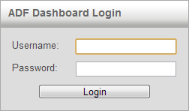To access the system via the WUI, connect the RJ45 cable to the ADF and power up the system using the S301 switch. The RJ45 connector is either placed on the bottom of the cabinet (P100, terminal X21) or inside the door at the control computer (P300, see figure below).

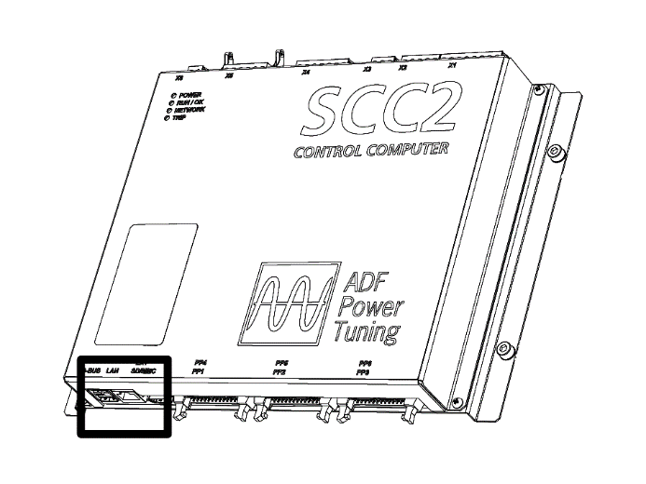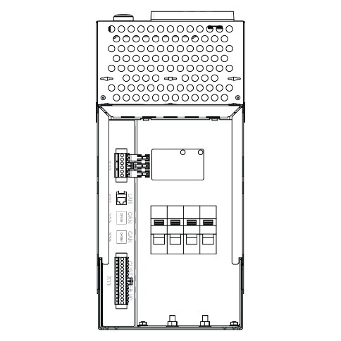

Now connect the other end of the RJ45 cable to the client PC and open a web browser. Note that the process of address assignment may take up to two minutes. Point the web browser to <http://169.254.254.254/> and you will be presented with a login screen.

Login with the username **admin** and blank password (default setting). The password of the **admin** user can be changed in the *Network settings window* after login.

Upon successful login, the username and password will be stored for the current session. This means that when refreshing the page or reconnecting for example after loading new software, login will happen automatically. Close all web browser windows or use the *Logout* link to end the session and log out.

### System setup

The system setup is now ready to be performed. This is typically only done during commissioning and its goal is to configure system and installation specific settings that are deemed unlikely to change after commissioning. The *System setup* window will automatically be shown upon entering the WUI while in *System setup mode*. All settings are described in the table below. When all settings are correct, click *Run diagnostics* to save the system setup and enter *Diagnostics mode*.

While it is recommended to commission the system using the WUI, the procedure can also be performed using the HMI in cases where bringing a computer is difficult. Please note that all systems are not equipped with an HMI. In any case, follow the actions in the below table.

|  |  |
| --- | --- |
| **Action** | **Description** |
| Module configuration | Select module type. *This item is pre-configured from factory.* |
| Nominal system voltage | Enter nominal system voltage, e.g., 400V |
| System frequency | Enter system frequency (50 or 60 Hz) |
| CT connection | Enter open-loop or closed-loop as above |
| CT ratio | Set primary rating of CT; only 5A secondaries are accepted. |
| Invert CT Polarity | In order to shift the phase of *all* CTs, enable this. |
| Number of parallel systems | See User Manual. |
| Grounding system | Select TN/TT or IT ground type. |
| Model key | *Preset from factory* |
| License key(s) | Enter license key(s) for additional functionality (if needed) |

Click *Run Diagnostics* to check that settings are OK.

### System states

The below figure shows the system states; the system can only be in one of the states at a time. 

In pre-charge, the DC bus is charged but the switch is off. In Stopped, the system is ready to be started. The main contactor is still open in this state. In autostart, the system is about to automatically start. In standby, the system is idling due to load current being too low. During Ready, the contactor is closed. In starting, the current output is increased until full operation is achieved. Operating is the state during normal operation. In any stage, the system may trip due to an alarm or warning which leads to a Trip state.

### Starting and stopping

When the DC-bus is fully charged the system is ready to be started. When the system is in the *Stopped* or *Operating* state, start and stop of the system can be performed using the LED key.

toolbar_starttoolbar_stopThe system can also be started and stopped by using the buttons in the WUI (Web User Interface):

The following methods exist to manipulate start/stop of the system:

* Manually – Buttons in the toolbar can be used to start and stop the system.
* Manually – Button on front of system can be used to start and stop the system.
* By automatic start – A start command can be automatically generated following power up and after a programmable delay without user intervention.
* By automatic restart – When enabled, the system will automatically attempt to restart after alarms.
* By digital input – The digital inputs can be used to generate start and stop commands
* By Modbus TCP – Modbus can be used to generate start and stop commands.

### toolbar_compCompensation Settings

This window allows configuration of all settings that concerns the compensation which is to be performed by the system. Open the window by clicking the ‘comp’ icon seen on the right.

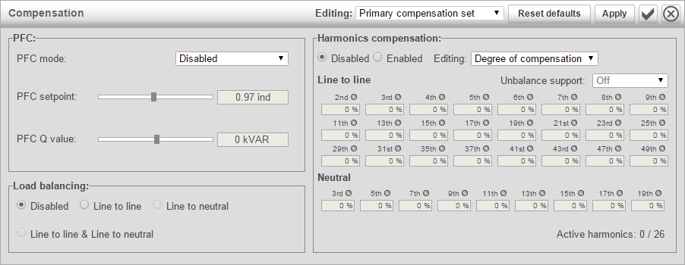

Power factor correction can be configured as **Disabled**, **Static**, **Dynamic, Dynamic (inductive)** or **Dynamic (capacitive)**. In static mode, a fixed amount of capacitive or inductive reactive power can be generated as specified in the *PFC Q* setting. In dynamic mode, the system will control the power factor measured on the CTs to the value specified in the *PFC setpoint* setting.

The load balancing setting can be configured as **Disabled**, **Line to Line**, **Line to Neutral** or both **Line to Line and Line to Neutral**. When Line to Line load balancing is enabled, the system will compensate for imbalances between phases.

In Line to Neutral, the compensation will take place between phases and the neutral connection.

The harmonics compensation can be set to **Disabled** or **Enabled**. The degree of compensation is configurable in percent for each harmonic with 0% being no compensation and 100% being complete elimination of the harmonic. The harmonics are divided in to two categories, line to line harmonics and line to neutral**\*\*** harmonics. Harmonics that can be compensated line to line are: 2nd**\***, 3rd, 4th**\***, 5th, 6th**\***, 7th, 8th**\***, 9th, 11th, 13th, 15th, 17th, 19th, 21st, 23rd, 25th, 29th, 31st, 35th, 37th, 41st, 43rd, 47th and 49th.  
And line to neutral**\*\***: 3rd, 5th, 7th, 9th, 11th, 13th, 15th, 17th and 19th. The selected compensation spectrum has to fit in to a total budget of 26 concurrent harmonic processing units. Each active line to line harmonic will by default consume one processing unit and each active line to neutral**\*\*** harmonic will consume two processing units.

### System Status

When the system is in the *Stopped* or *Operating* state, measurement data is shown in the root menu of the HMI.

Active alarms will also be displayed on the HMI. Persistent alarms will be added to the end of the list, thus making it impossible to acknowledge all alarms. Thus, when an alarm code is encountered the second time around, the complete list of alarms has been traversed. Alarms can be acknowledged by pressing the start/stop button when it is solid red.

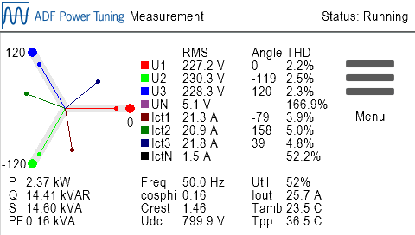

|  |  |  |
| --- | --- | --- |
|  | **Comsys AB** Fältspatvägen 4 SE-224 78 LUND, Sweden Tel +46 (0)10 209 68 00 Fax +46 (0)10 209 68 05 E-mail: info@comsys.se website: www.comsys.se | **Agent:** |
| Comsys AB does not assume any responsibility for use of any product or method described and also reserves the right to make changes at any time without prior notice in order to improve design and supply the best possible products. | | |