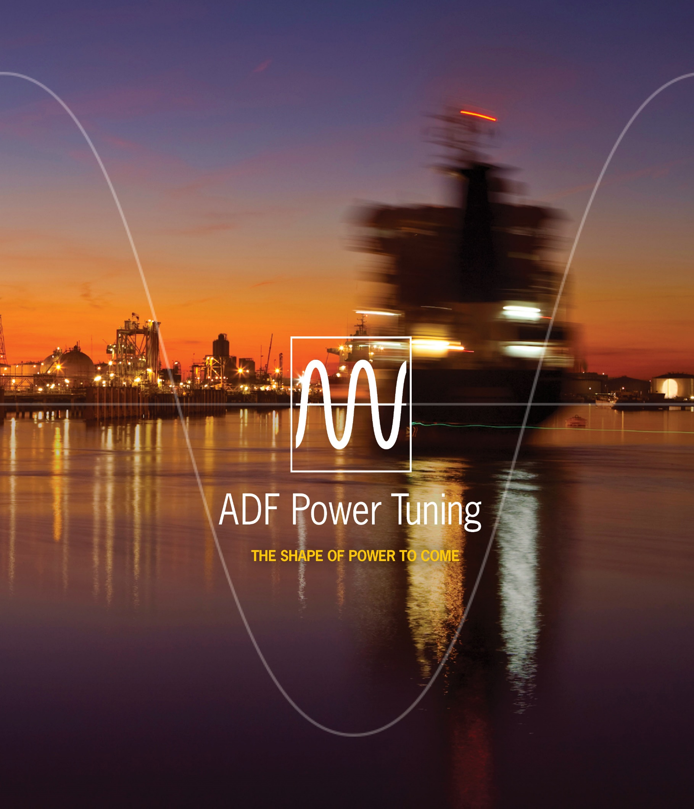



ADF P100/P100N Hardware Manual

## Safety notes

Read these instructions carefully and look at the equipment to become familiar with the product before trying to install, operate or maintain it. The following special messages may appear throughout this manual to warn of potential hazards or to call attention to that which clarifies or simplifies a procedure:

|  |  |
| --- | --- |
| ⚠ | **ATTENTION:** Identifies information about practices or circumstances that can lead to personal injury or loss of life, property damage, or economic loss. |

|  |  |
| --- | --- |
| NOTE | Provides additional information to clarify or simplify a procedure. |

|  |  |
| --- | --- |
| ⚠ | **ATTENTION:** Only qualified electrical personnel familiar with the construction and operation of this equipment and the hazards involved should install, adjust, operate, or service this equipment. Read and understand this manual and other applicable manuals in their entirety before proceeding. Failure to observe this precaution could result in severe bodily injury or loss of life.  **ATTENTION:** The product contains DC bus capacitors which retain hazardous voltages in excess of 1000 V after input power has been disconnected. After disconnecting input power, wait at least sixty (60) minutes for the DC bus capacitors to discharge and then check the voltage with a voltmeter to ensure the DC bus capacitors are discharged before touching any internal components. Failure to observe this precaution could result in severe bodily injury or loss of life.  **ATTENTION:** This product may have been modified from factory in order for the auxiliary power to be supplied externally. After disconnecting main fuses, the external auxiliary power must also be disconnected.  **ATTENTION:** Before manipulating current transformers, make sure that the secondary is short-circuited. Never open the secondary of a loaded current transformer. You must always wear isolating gloves and eye-protection when working on electrical installations. Also make sure that all local safety regulations are fulfilled.  **ATTENTION:** Only qualified personnel or other trained personnel who understand the potential hazards involved may make service, updates, troubleshooting, repair or similar work to the product. Any such activities not made corrects may result in uncontrolled operation. Failure to observe this precaution could result in damage to equipment and bodily injury. Although reasonable care has been taken to provide accurate and authoritative information in this document, no responsibility is assumed by **Comsys** for any consequences arising out of the use of this material. |

The information in this document is subject to change without notice.

© 2008 – 2018 Comsys AB. All rights reserved.

## Product identification

The product identification label is found at the front of the ADF. Remember to check that your supply is compatible with the technical data stated on the label before installing and commissioning the Active Filter.

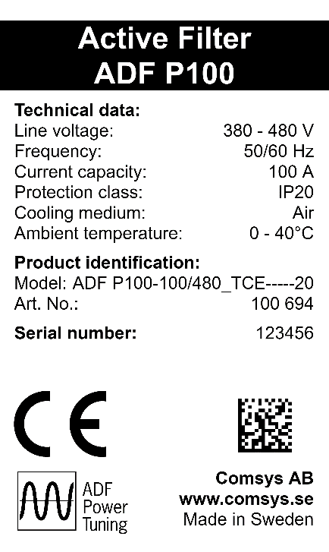

This manual applies to products listed in the table below:

Table : Applicable ADF P100 models

|  |  |  |  |
| --- | --- | --- | --- |
| Product line | Models | Current rating | Voltage |
| ADF P100  Air cooled,  3 wire | ADF P100-70/480 | 70 ARMS | 208 – 480 V |
| ADF P100-100/480 | 100 ARMS |
| ADF P100-130/480 | 130 ARMS |
| ADF P100-90/690 | 90 ARMS | 480 – 690 V |
| ADF P100  Air cooled,  4 wire | ADF P100N-100/415 | 100 ARMS  300 ARMS (Neutral) | 208 – 415 V |
| ADF P100v2B  Air cooled,  3 wire | ADF P100v2B-50/480 | 50 ARMS | 208 – 480 V |
| ADF P100v2B-75/480 | 75 ARMS |
| ADF P100v2B-90/480 | 90 ARMS |
| ADF P100v2B-120/480 | 120 ARMS |
| ADF P100v2B-150/480 | 150 ARMS |

## Standards

These products are CE compliant, which means that the products are in conformity with the European Community low voltage directives 72/23/EEC and 93/68/EEC and it bears the CE label.

The following standards apply:

Table : Standards

|  |  |
| --- | --- |
| Standards | |
| Electromagnetic compatibility | EN 61000-6-2, EN 61000-6-4 |
| Electrical design and safety | EN 50178 / VDE0160 |
| Protection class | IP20 according to IEC 529  IP21 according to IEC 529 (option) |
| Approval marking | 72/23/EEC, 93/68/EEC CE-mark |

## Document revision

Table : Document revision

|  |  |  |  |
| --- | --- | --- | --- |
| Revision | Date | History: | Status: |
| A | 2013-01-21 | INITIAL RELEASE HARDWARE PREVIEW | RELEASED |
| A1 | 2013-01-24 | MINOR FIXES | RELEASED |
| B | 2013-03-21 | MINOR FIXES | RELEASED |
| C | 2015-11-20 | UPDATE FOR ADF P100N and 690 V | RELEASED |
| REV05 | 2018-01-26 | NEW DESIGN, IP21 included, ADF P100v2B included | RELEASED |
|  |  |  |  |
|  |  |  |  |

## Contents

Safety notes 3

Product identification 4

Standards 5

Document revision 5

Contents 6

List of figures 9

List of tables 11

1 Overview 13

1.1 Content 13

1.2 Organization of manual 13

1.3 Related documentation 13

2 Active Filter Overview 14

2.1 Introduction to the Technology 14

2.1.1 The Problem: Poor Power Quality 14

2.1.2 The Solution: Active Filters 14

2.1.3 Common applications which can benefit from Active Filters 14

2.1.4 How Active Filters Work 14

2.2 System Overview 15

2.2.1 Features 15

2.2.2 Main components overview 16

2.2.2.1 User interface (HMI-3 Extended) (optional) 16

2.2.2.2 PIB - Power Indication Button (HMI-3 Basic) 17

2.2.2.3 Power Electronics Module (PEM) 17

2.2.2.4 Control Module (CM) 17

2.2.2.5 Control computer (SCC2) 17

2.2.2.6 Auxiliary voltage transformer (T101) 17

2.2.2.7 Auxiliary fuse block (F501) 18

2.2.2.8 Power connection terminals (X10) 18

2.2.2.9 Earth connection (PE) 18

2.2.2.10 User signal interface (X11) 18

2.2.2.11 Current transformer interface (X12) 18

2.2.2.12 LAN connection (X21) 18

2.2.2.13 Multi-master interface (X22 & X23; optional) 18

2.3 Filter configuration 19

3 Getting started 21

3.1 Receiving and unpacking 21

3.2 Installation 21

3.3 Configuration and Commissioning 21

4 Installation 22

4.1 Unpacking the Active Filter 22

4.1.1 Before unpacking and Installation/Commissioning 22

4.1.2 Lifting the Active Filter in its box 22

4.1.3 Lifting the Active Filter 23

4.1.4 Wall mounting and preservation of the Active Filter 24

4.1.5 Mounting IP21 roof (optional) 25

4.1.6 Storage conditions 25

4.1.7 Transport conditions 25

4.2 Environmental conditions 26

4.2.1 Operating conditions 26

4.2.2 Physical conditions 26

4.2.3 Cooling air flow requirements 26

4.3 Connection of the Active Filter 27

4.3.1 Overview connection terminals of the ADF P100 27

4.3.2 Power connection terminals (X10) 27

4.3.2.1 Selection of power cable size 28

4.3.2.2 Main fuse selection 29

4.3.3 Protective earth (PE) connection 29

4.3.4 Auxiliary fuse selection 29

4.3.5 Auxiliary Transformer Setup 30

4.3.6 User signal interface (X11) 31

4.3.7 Current transformer terminals (X12) 31

4.3.7.1 Selection of current transformers 32

4.3.7.2 Recommended current transformer cable size 32

4.3.7.3 Location of current transformers 33

4.3.7.4 Connection and wiring of current transformers 33

4.3.7.5 Connection of current transformers with paralleled systems 35

4.3.7.6 Use of summation current transformers 35

4.3.8 Local area network (X21) 35

4.3.9 Multi-master bus (X22 & X23; optional) 36

5 Maintenance 37

5.1 Biannual inspection 37

5.1.1 Removal of covers 37

5.1.2 Visual inspection 37

5.1.3 Cleaning 38

5.1.4 Electrical connection 38

5.1.5 Change and inspection of internal fuse 38

5.1.6 Cooling system 38

Appendix A Technical Specifications 39

A.1 Technical Data – ADF P100 39

A.2 Technical Data – ADF P100N 40

A.3 Technical Data – ADF P100v2B 41

A.4 Dimensions – ADF P100 42

A.5 Dimensioning – ADF P100N 43

A.6 Dimensions – ADF P100 (IP21) 44

A.7 Dimensions – ADF P100N (IP21) 45

Appendix B Compatibility with passive compensation 46

Appendix C Harmonics derating 47

C.1 Single harmonic maximum current 47

C.2 Determining the thermal limit 48

C.3 Summary 48

Appendix D Power derating 49

D.1 Altitude derating 49

D.2 Overtemperature derating 49

## List of figures

Figure 1: Basic operating principle 13

Figure 2: Uncompensated load current (left), Compensation current (middle), Compensated net current (right) 13

Figure 3: ADF P100N external overview with HMI 14

Figure 4: ADF P100 with removed CM hood 14

Figure 5: ADF P100 with removed CM hood 14

Figure 6: Customer Electrical Interface of ADF P100 15

Figure 7: Customer Electrical Interface of ADF P100N 15

Figure 8: Correct lifting of the Active Filter 21

Figure 9: Footprint for wall mounting the Active Filter (in mm) 22

Figure 10: Mounting IP21 roof 23

Figure 11: Air flow in ADF P100N 25

Figure 12: Air flow in ADF P100 25

Figure 13: X12 terminals; with closed short circuit 29

Figure 14: Current Transformer placement diagram – closed loop 31

Figure 15: Current Transformer placement diagram – open loop 31

Figure 16: No current transformer in Sensorless Control 31

Figure 17: ADF P100 Current Transformer connection diagram – closed loop 32

Figure 18: ADF P100N Current Transformer connection diagram – closed loop 32

Figure 19: Current Transformer connection diagram – paralleled units 33

Figure 20: Example setup for Multi-master operation 34

Figure 21: Dimensions ADF P100 (in mm) 40

Figure 22: Dimensions ADF P100N (in mm) 41

Figure 23: Dimensions ADF P100 IP21 (in mm) 42

Figure 24: Dimensions ADF P100N IP21 (in mm) 43

Figure 25: Connection of an Active Filter unit, passive compensation, and location of CTs. 44

## List of tables

Table 1: Applicable ADF P100 models 4

Table 2: Standards 5

Table 3: Document revision 5

Table 4: PIB color coding 15

Table 5: Maximum storage conditions 23

Table 6: Maximum transport conditions 23

Table 7: Maximum operating environmental conditions 24

Table 8: Minimum air flow requirements 24

Table 9: ADF Power connection data 26

Table 10: Recommended cable sizes 26

Table 11: Auxiliary fuse selection 27

Table 12: Voltage range 208 – 415 V 28

Table 13: Voltage range 380 – 480 V 28

Table 14: Voltage range 480 – 600 V 28

Table 15: Voltage range 690 V 28

Table 16: External interface terminal X11 29

Table 17: External interface terminals X12 30

Table 18: Current transformer (CT) specification 30

Table 19: Burden as function of cable size and length 30

Table 20: ADF CT connection data 30

Table 21: CT connection table 32

Table 22: Technical specifications ADF P100 37

Table 23: Technical specifications ADF P100N 38

Table 24: Technical specifications ADF P100v2B 39

Table 25: Maximum current output on single harmonics 45

# Overview

## Content

This manual describes the hardware, installation and maintenance topics of the Comsys ADF P100 series of active filters.

## Organization of manual

The ADF P100 manual is organized in two parts, namely:

1. ADF P100/P100N Hardware Manual, doc no 1 199 273 (this document)
2. ADF P100/P300 User Manual, doc no 1 199 172

The Hardware Manual covers hardware related issues, such as installation, cable selection, CT configuration, preventive maintenance, and troubleshooting.

The user manual covers issues which are governed by the installed software in the system such as operation, initial configuration and commissioning. Hence, when the system is updated, a new User Manual is supplied.

## Related documentation

* ADF P100/P300 User Manual; doc no 1 199 172
* ADF P100 Circuit diagram
* ADF P100/P300 Service Manual

# Active Filter Overview

## Introduction to the Technology

Comsys offers a new generation of high performance power quality products for industrial, utility and commercial applications based on active filter technology, which removes the losses and restores the natural wave shape of the current.

### The Problem: Poor Power Quality

Transients, harmonics, voltage variations (including flicker) and unbalance puts the power grid, machines, motors and computer equipment under considerable stress resulting in disturbances, production stops, waste of energy and reduced lifetime. These terms, among others, constitute power quality.

A large part of the equipment connected to the power grid creates disturbances, voltage variations and undesired harmonics that pollute the grid. This pollution generates losses, disturbances, productions stops and reduces expected lifetime of cabling, transformers and other installed equipment as a cause of the excess load.

This leads to decreased capacity in the electrical network, less effective electrical power consumption and energy losses that transforms into both technical and economic costs.

### The Solution: Active Filters

Traditionally fixed, electro-mechanical and semiconductor controlled filters and/or compensators have been used to limit or minimize power quality problems in the network.

They operate mainly on a fixed or stepped basis using passive elements. All these solutions suffer from the same drawbacks – they add losses, are installation specific and have no ability to adapt to or follow dynamic load changes.

The Active Dynamic Filter (ADF) eliminates loss creating behaviors such as harmonics, flicker, voltage variations, resonances and reactive energy using a highly dynamic, step less digitally controlled compensation and filtering approach. By continuously monitoring the network and injecting exactly the right amount of compensation current – at exactly the right time – the most efficient and accurate solution to any power quality problem can be achieved.

This approach enables the current waveform to be restored instantaneously, the current consumption to be lowered and changes in load or installation conditions to be fully compensated at all times.

### Common applications which can benefit from Active Filters

* Harmonic/reactive power suppression in 3-phase systems
* Industrial production machines (e.g. mills, presses)
* Variable speed drive systems (AC drives, DC drives)
* Electrical welding systems
* Plastic machinery (extruders, injection molders, film treatment machines)
* Power generation systems and UPS equipment
* Electrolytic processes
* Induction heating

### How Active Filters Work

An active filter is basically a very advanced computer controlled current generator with the ability to produce any shape or form of current with little or no delay.

A simplified diagram of the operating principle is shown in Figure 1. The system is connected in parallel with the load requiring compensation.

Currents and voltage delivered from the network are measured and analyzed, to determine if disturbances such as e.g. reactive displacement and/or harmonics are present.

The system injects compensation currents which is the exact opposite of the e.g. harmonics and/or reactive displacement to cancel out the undesired behavior of the load.

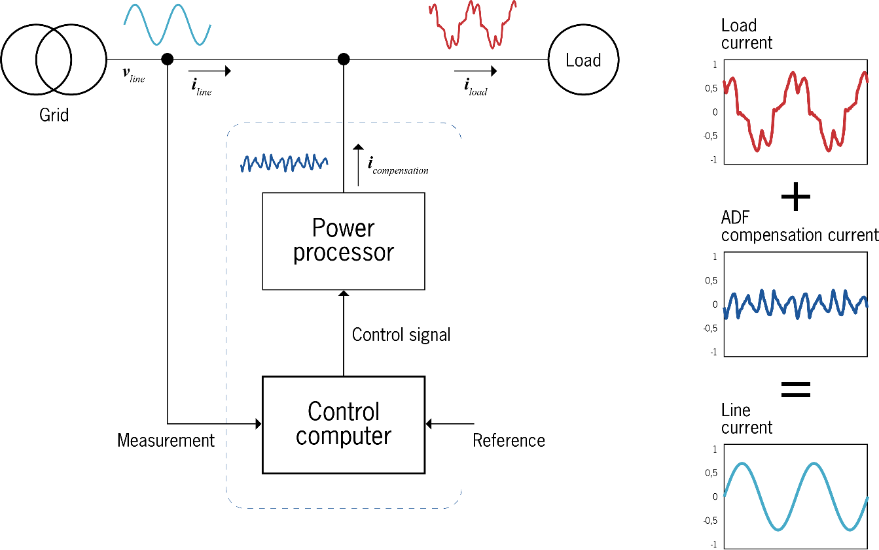

Figure : Basic operating principle

The Figure 2 shows how the current consumed by an electrical load may look like prior to and during compensation. Before compensation, the current consists of several harmonics in addition to the fundamental, which are apparent from the current’s deformed waveform. After injection of the compensation current, the load current’s natural sinusoidal waveform is restored and the loss creating behaviors have been eliminated.

The function of the power transmission system is restored, which leads to saved energy, lower disturbances or in short – improved power quality and significantly lowered costs in electrical installations.

Figure : Uncompensated load current (left), Compensation current (middle), Compensated net current (right)

## System Overview

The Active Filter ADF P100 is a stand-alone and modular high power active power filter. It can be installed inside a machine as OEM, inside a cabinet in system integration or directly on the wall. Several ADF P100 units can work in parallel.

### Features

General features:

* Compact design in ready-to-use wall mounted enclosure
* High performance and reliability
* Advanced digital control and low response time
* Several units can be operated in parallel for higher power ratings
* Suitable for embedded solutions
* Non-overloadable and insensitive to changes in network or load conditions
* Easy installation, commissioning and maintenance

### Main components overview

This section describes the major components of the ADF P100 Active Filter.

|  |  |
| --- | --- |
| Figure : ADF P100N external overview with HMI | Figure : ADF P100 with removed CM hood |
| Figure : ADF P100 with removed CM hood |

#### User interface (HMI-3 Extended) (optional)

All settings, configuration and operation can be performed from the HMI (Human Machine Interface) panel, see Figure 3. Please refer to the ADF P100/P300 User Manual (1 199 172) on how to use the HMI.

#### PIB - Power Indication Button (HMI-3 Basic)

Basic operations like start and stop, can be performed on the PIB. The button also shows basic operation information on an indication light, integrated in the button.

The ADF is powered ON by pressing this button short and powered OFF by pressing the button for two seconds.

Table : PIB color coding

|  |  |  |
| --- | --- | --- |
| Color | Description | Button action |
| Fading red | System in trip and log is being written to SD-card | None |
| Solid red | System in trip | Acknowledge all alarms |
| Fading yellow | Pre-charge / all other states | None |
| Solid yellow | System stopped | Start system |
| Fading green | System is in standby mode | Stop system |
| Solid green | System is running | Stop system |
| None | System is powered off | Boot system |

#### Power Electronics Module (PEM)

The top part of the ADF P100, upper three quarter in Figure 3, is the Power Electronics Module that generates the compensation currents. The power processor contains power electronics such as IGBT modules, IGBT driver electronics, EMC-filter, DC-storage, cooling fans and line filtering components.

#### Control Module (CM)

The Control Module has three major functions; control of the power processor, auxiliary power supply, and customer interface. It contains most automation components.

|  |  |
| --- | --- |
| Figure : Customer Electrical Interface of ADF P100 | Figure : Customer Electrical Interface of ADF P100N |

#### Control computer (SCC2)

The SCC2 control computer is a stand-alone digital processing system containing all functions for controlling the power processor modules. It also features protection circuitry for monitoring and main contactor control.

#### Auxiliary voltage transformer (T101)

The auxiliary voltage transformer (T101) transforms mains voltage to 230 VAC.

#### Auxiliary fuse block (F501)

Auxiliary fuse block (F501), located inside the unit, protects voltage measurement circuits, pre-charging circuits and auxiliary power systems in the Active Filter.

#### Power connection terminals (X10)

Used for connection of mains to the system. See section 4.3.2 for detailed connection information. The terminals are placed in the bottom section of the Control Module.

#### Earth connection (PE)

Main PE connection.

#### User signal interface (X11)

The user signal interface terminals, X11, are used for interface to external devices via alarm outputs and digital inputs. See section 4.3.6 for more information on how to connect digital inputs and outputs.

#### Current transformer interface (X12)

Current transformer interface terminals, X12, are used for connecting current transformers. See section 4.3.7 for more information on how to connect current transformers (CT’s).

#### LAN connection (X21)

LAN connection for interfacing the ADF Dashboard Web-User-Interface. X21 also offers a Modbus TCP interface (optional).

#### Multi-master interface (X22 & X23; optional)

MM-bus connections X22 and X23 for interconnecting ADF systems for parallel operation in closed loop setup.

## Filter configuration

The ADF P100 filter is available in a variety of configurations. The product configuration is defined by the product string. The product string consists of the basic type of product, such as ADF P100-120/480, but also a list of factory built-in options.

A variety of the ADF P100 is the so called “v2B”. This is a facelift of the ADF P100 480 V versions. It can be identified by its current ratings with 50/75/90/120/150 A. The facelift version does not differ very much from its previous version and does not get an own article name for that. “v2B” will replace the previous version completely.

Please note that other options exist that are not immediately part of the product string, such as software licenses that do not have a hardware impact. The nomenclature of the product string is defined as below:

ADF PmodQ-cur/vol_{OPTION STRING: ABCDEFGHIJ}

ADF P100-120/480_T-E-----20

All positions are always visible within the product string, except for ‘Q’ that is a qualifier that enables a certain type of product. In the P100 line, the only available qualifier is ‘N’ for the P100N product which means the product is configured as three-phase, four-wire.

When an option is enabled, it is lit up in the string. For example, the multi master option is on position B in the string ABCDEFGHIJ above, and is indicated by letter ‘C’ so it can immediately be seen if multi-master is enabled by looking below:

ADF P100-120/480_TCE----20

A similar system without multi-master looks like the following:

ADF P100-120/480_T-E----20

Also note that the encapsulation class (ingress protection) is documented in the last two letters. 20 in this case means IP20. All relevant ADF P100 codes are listed in the table below:

Tabell : ADF P100 product string

|  |  |  |  |
| --- | --- | --- | --- |
|  | Position | ADF | Active Dynamic Filter |
|  | **Product Type (mod) and Qualifier (Q)** | | |
|  | **ADF P100*Q***  **ADF P100(N)**-120/480__T-E-----20 | **P100** | 3phase-3wire, air cooled, wall-mounted Active Dynamic Filter |
|  | **P100v2B** | 3phase-3wire, air cooled, wall-mounted Active Dynamic Filter |
|  | **P100N** | 3phase-4wire, air cooled, wall-mounted Active Dynamic Filter |
|  | **Current Rating (cur)** | | |
|  | **cur**  ADF P100(N)-**120**/480__T-E-----20 | **70, 100, 130**  **50, 75, 90, 120** | 70/100/130 A (50/75/90/120 A for v2B) rating on ADF P100 in 415/480 V versions (IEC) |
|  | **100** | 100 A rating on ADF P100N in 415 V version (IEC) |
|  | **90** | 90 A rating on ADF P100 in 600/690 V versions (IEC) |
|  | **Voltage Level (vol)** | | |
|  | **vol**  ADF P100(N)-120/**480**_T-E-----20 | **415** | Permissible voltage levels are: 215/230/245/385/400/415 V |
|  | **480** | Permissible voltage levels are: 380/400/420/440/460/480 V |
|  | **600** | Permissible voltage levels are: 475/500/525/550/575/600 V |
|  | **690** | Permissible voltage level is: 690 V |
|  | **Options (ABCDEFGH)** | | |
|  | **Grounding System (A)** | | |
|  | **A**  ADF P100(N)-120/480_**T**-E-----20 | **T** | TN/TT grounding system (standard if not otherwise specified) |
|  | **I** | IT grounding system |
|  | **Multi-master (B)** | | |
|  | **B**  ADF P100(N)-120/480_T**-**E-----20 | **C** | Multi-master option included |
|  | **HMI (C)** | | |
|  | **C**  ADF P100(N)-120/480__T-**E**-----20 | **B** | Basic HMI with PIB only (standard if not otherwise specified) |
|  | **E** | Extended HMI with PIB and 4.3’’ color touchscreen interface |
|  | **Reserved (unused) option codes (DEFGH)** | | |
|  | **DEFGH**  ADF P100(N)-120/480__T-E**-----**20 | - | **Currently not in use** |
|  | **Protection class (IJ)** | | |
|  | **IJ**  ADF P100(N)-120/480_T-E-----**20** | **20** | IP20 (IEC/CE systems only) |
|  | **21** | IP21 (IEC/CE systems only) |

# Getting started

This section is intended to help you get through to operate the Active Filter with the least work on your part. Guidance and hints are provided. First it is important that you read and observe the safety notes in the beginning of this manual to help avoid damage to equipment, installation and persons.

## Receiving and unpacking

On receiving the unit read notes in section 4.1. If the system is to be transported on site, please be sure to avoid excessive strains. In particular, no components must be bent, or isolating distances altered in the course of transportation or handling. No contact must be made with electronic components and contacts. Also note that all operations serving transport, installation and commissioning as well as maintenance must to be carried out by skilled technical personnel.

Active Filters contain electrostatic sensitive components which are liable to damage through improper use. Electric components must not be mechanically damaged or destroyed (potential health risks).

## Installation

It is important to prepare the installation site prior to installing and connecting the Active Filter. In the section 4, important information such as location of terminals, cable size recommendations, ADF P100 over current protection and cooling air flow requirements are discussed. To maintain operation and long equipment life it is vital to keep environmental conditions in accordance with the specifications.

Current transformer (CT) selection is important for good performance. Read about CT selection and connection in section 4.3.7 and if possible use separate CTs, not shared with other equipment e.g. power quality meters.

Notice that an operation without current transformers is also possible. “Sensorless Control” is an optional operation mode.

Good earth connection is also important to achieve best results and electrical safety as described in the section 4.3.3.

It is important that any materials or method for connection used is within limits with respects to local safety regulations. Also make sure that appropriate fuses are fitted in the mains connection.

## Configuration and Commissioning

The Active Filter has extensive functionality built-in for several modes of operation.

The ADF P100/P300 User Manual (1 199 172) details how to configure the software parameters for the ADF P100.

# Installation

## Unpacking the Active Filter

Each Active Filter is delivered in packaging suitable for transportation. Upon reception of the Active Filter, visually inspect that the packaging is in good condition. Verify that all below listed items are present in the package:

* ADF P100/P100N Hardware Manual, doc no 1 199 273 (this document)
* The ADF P100/P300 User Manual (1 199 172)

|  |  |
| --- | --- |
| ⚠ | **ATTENTION:** Before unpacking and installing the Active Filter please read through the following pages THOROUGHLY to make sure that it is handled in the right way.  The unit is heavy and weighs up to 147 kilograms / 324 lbs.  Do not attempt to move the unit before reading the lifting instruction and act accordingly.  Attempt to move the equipment without proper equipment and not according to instructions may result in damage of the equipment and injury. |

### Before unpacking and Installation/Commissioning

Before moving the Active Filter without its protective packaging please pay extra attention to the section in this document that handles lifting. During transport and storage and before commissioning, keep the system protected from dust and water ingression.

|  |  |
| --- | --- |
| ⚠ | **ATTENTION:** Make sure to protect the Active Filter at all times, especially during installation since the product contains very sensitive power electronics. |

### Lifting the Active Filter in its box

The ADF P100 can be handled by forklifts and cranes as long as it is packaged in its protective packaging.

### Lifting the Active Filter

The ADF P100 must be lifted and moved according to the instructions in this section.

Start by removing part of freight box in such a way that the ADF P100 is accessible from all sides and top when lying on its back. Only the part of the freight box under the ADF P100 back is then left. The ADF P100 is screwed to the pallet with one screw on the top and one at the bottom.

The Active Filter may only be lifted in the lifting ears on top and bottom of the Active Filter. This is only possible without the optional IP21 cover. The length of the straps must exceed 220 mm / 9” and be of the same length according to Figure 8. Protect the ADF P100 from scratching and other damages during lifting, by adding soft protective material between the ADF P100 and other objects.

The filter may also be manually lifted using special metal rods. Insert the metal rods in the lifting holes and manually lift the filter. The metal rods are not included. Generally round metal rod(s) can also be used.

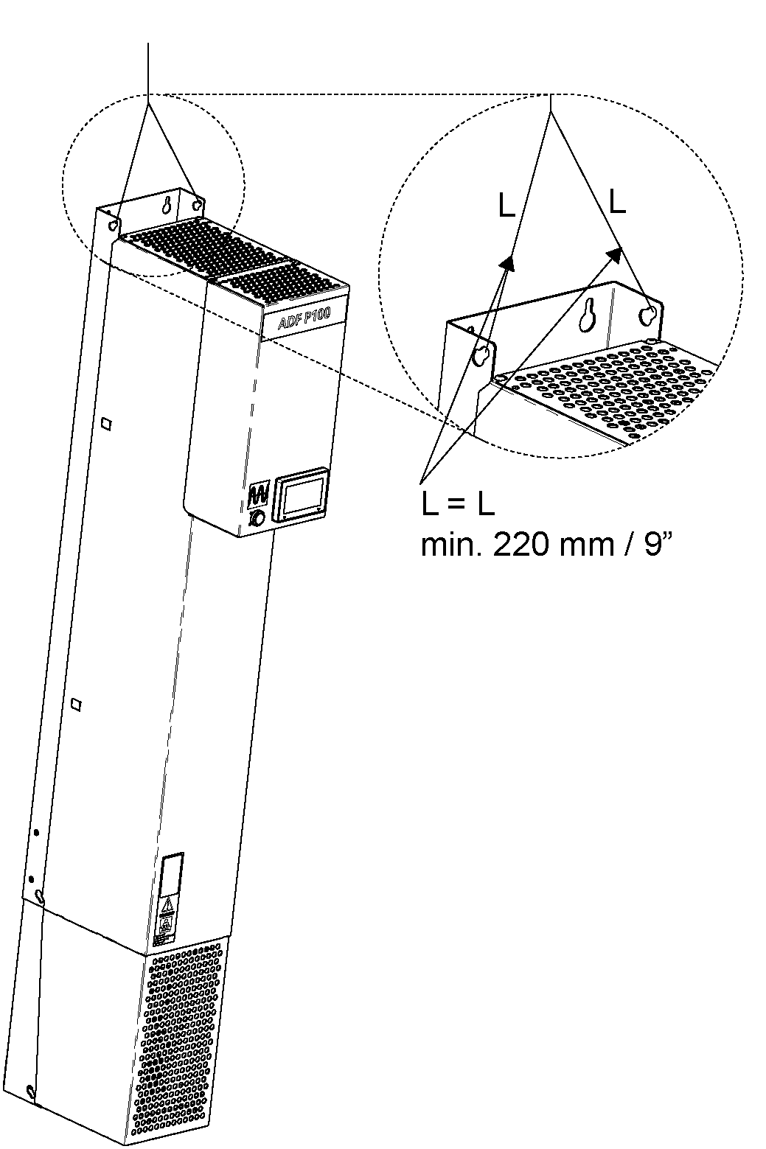

Figure : Correct lifting of the Active Filter

If moving the Active Filter with for example a fork lift, it may only be moved lying down on its back, not on its sides nor standing.

### Wall mounting and preservation of the Active Filter

Make sure the wall and the fastening bolts can support the weight (up to 170 kg) of the Active Filter. Start with fastening the screws on the top (use M10 with flat head) in the wall as suggested by the footprint in Figure 9. Leave space between the head of the screw and the wall for the back side of the Active Filter to be fitted.

Lift the Active Filter into place over the keyholes, push it flat to the wall and lower it in place. Tighten the screws. The screws in the bottom can then be mounted.

The bottom screw holes are extended to long holes for backwards compatibility. Older systems have a hole distance of 178 mm. New systems to change to a hole distance of 156 mm (same as in the top of the system). Currently the ADF P100 has a long hole to support both distances.

Comsys suggests using the 156 mm distance.

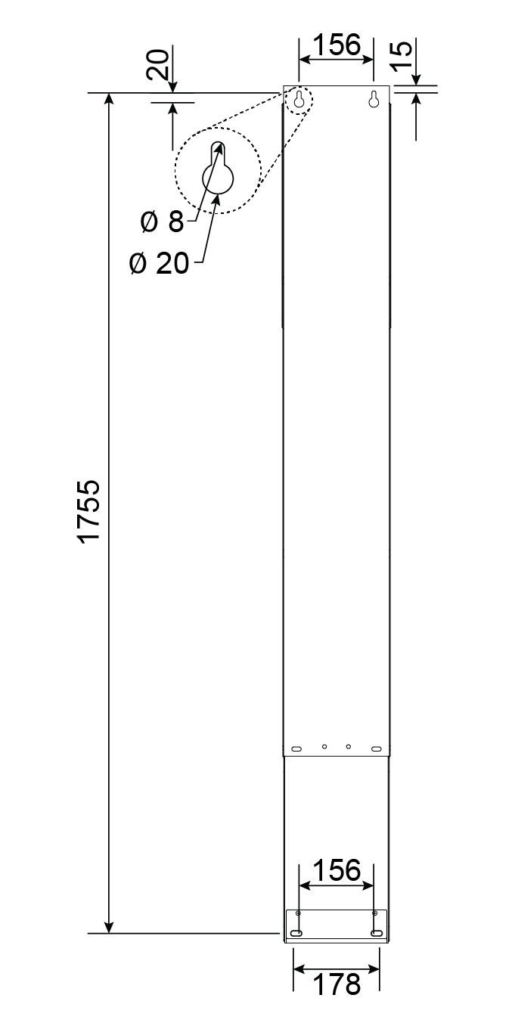

Figure : Footprint for wall mounting the Active Filter (in mm)

After the Active Filter has been mounted on the wall, protect the system from dust and other harmful particles.

### Mounting IP21 roof (optional)

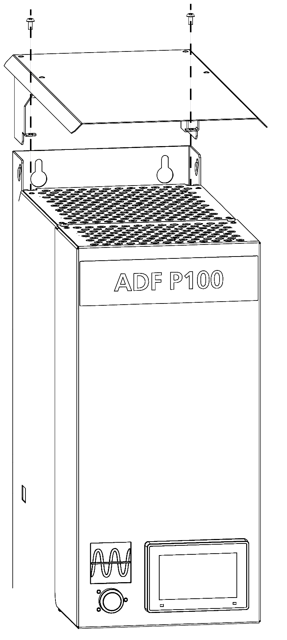

Figure : Mounting IP21 roof

The ADF P100(N) is available with an IP21 option. This option is not mounted when shipping.

To mount the IP21 roof, two screws (size 3 hex-screw) in top of the ADF P100(N) needs to be removed. The IP21 roof must be put on top and the screws then needs to be put back.

### Storage conditions

During storage of the unit, the unit should be kept within the following conditions. The conditions are acceptable only when the unit is kept in its shipping packaging.

Table : Maximum storage conditions

|  |  |
| --- | --- |
| Maximum storage conditions (in protective shipment package) | |
| Temperature | -25 °C to 70 °C (-13 °F to 158 °F) |
| Relative humidity | Less than 95 %, non-condensing |
| Environmental conditions | Chemical class 3C3  Mechanical class 3S3 |

### Transport conditions

During transport, the unit should be kept within the following conditions. The conditions are acceptable only when the unit is kept in its shipping packaging.

Table : Maximum transport conditions

|  |  |
| --- | --- |
| Maximum transport conditions (in protective shipment package) | |
| Temperature | -25 °C to 70 °C (-13 °F to 158 °F) |
| Relative humidity | Less than 95 %, non-condensing |
| Environmental conditions | Chemical class 3C3  Mechanical class 3S3 |

## Environmental conditions

### Operating conditions

The unit is suitable for indoor operation only. If the unit is operated within the below limits, full power may be utilized. During more demanding conditions, the unit will be derated when approaching full power.

The unit must be placed in a well-ventilated area. For cooling air flow requirements, see section 4.2.3.

Table : Maximum operating environmental conditions

|  |  |
| --- | --- |
| Maximum operating environmental conditions | |
| Temperature | 0 °C to 50 °C, derating applies above 40 °C  32 °F to 122 °F, derating applies above 104 °F |
| Relative humidity | Less than 95 %, non-condensing |
| Altitude | 1000 m (3300 ft) Derating may be required at higher altitude. For more details, see “Appendix D Power derating” |
| Environmental conditions | Chemical class 3C2  Mechanical class 3S2 |

|  |  |
| --- | --- |
| ⚠ | **ATTENTION:** Make sure that the unit is installed in an environment without conductive or corrosive dust. If conductive or corrosive dust is present extra precautions must be taken. Contact your COMSYS representative. |

### Physical conditions

There should be a minimum of 100 mm / 4” clearance to the ceiling above the roof of the unit in order not to obstruct cooling air flow.

In front of the unit, there should be a minimum clearance of 400 mm / 16” to allow removal of cover. However, make sure to enable service access, for example it must be possible to physically access the unit from the front. Also, in front of the unit, there should be a minimum clearance of 100 mm / 4” to avoid restriction of air intake, assuming no external restrictions for air flow, for example if the ADF P100 is placed in a cabinet.

If the unit is placed inside an enclosed cabinet, the door is not considered a restriction. However, consider that cooling air must not be restricted see section 4.2.3.

There is no minimal clearance to floor, however make sure that mains and signal cables have space for bending and connecting. There is no minimal clearance sideways however consider that the unit can become hot under operation.

Local regulations may impose stricter demands.

### Cooling air flow requirements

The cooling air flow requirements are dependent on operating conditions and load cycles. The following table states the maximum demanded air flow from each ADF P100:

Table : Minimum air flow requirements

|  |  |  |
| --- | --- | --- |
| Model | Maximum air flow | Maximum losses |
| ADF P100-70/480  ADF P100-100/480  ADF P100-130/480  ADF P100-90/690  ADF P100N-100/415 | 600 m3/h | 1500 W  2235 W  2970 W  2969 W  2235 W |
| ADF P100v2B-50/480  ADF P100v2B-75/480  ADF P100v2B-90/480  ADF P100v2B-120/480  ADF P100v2B-150/480 | 600 m3/h | 1600 W  2535 W  3180 W  3155 W  3225 W |

It is crucial that the Active Filter can utilize the needed air flow during maximum operating conditions. The cooling air may not exceed 50 °C / 122 °F under any circumstances. Derating applies above 40 °C / 104 °F.

|  |  |
| --- | --- |
| ⚠ | **ATTENTION:** Make sure that the ambient temperature is below 50 °C / 122 °F under all circumstances.  Make sure that the air drawn into the unit does not contain corrosive or conductive gases of any kind. Make sure that the physical mounting guidelines are followed and that no obstruction lower the air flow. Take care of the hot air emitted from the unit in a proper way.  Failure to observe these guidelines may result in premature aging or failure of the equipment. |

The Active Filter contains internal fans that will ensure that the air flow reaches the needed capacity during maximum operating conditions. The emitted hot air must be taken care of by the room housing the unit. Hot air is emitted from the top of the unit, and to a smaller extent, from the front in the ADF P100N according to the figure below.

|  |  |
| --- | --- |
| Figure : Air flow in ADF P100N | Figure : Air flow in ADF P100 |

## Connection of the Active Filter

The Active Filter has three main connector terminals, X10 for the power interface, X11 for external user functionality signals and X12 for CTs, as seen in Figure 6 and Figure 7. They are located at the bottom of the unit.

### Overview connection terminals of the ADF P100

In Figure 6 the connection area and the terminal names for the ADF P100 products can be seen.

### Power connection terminals (X10)

The mains power connection is made at terminals X10 (see Figure 6 for ADF P100 and see Figure 7 for ADF P100N), found in the bottom of the unit. X10 accepts a wide range of different cable types (copper or aluminum, solid or stranded with or without ferrule and ferrule with or without plastic sleeve) up to 95 mm2.

Table : ADF Power connection data

|  |  |
| --- | --- |
| ADF Power connection data | |
| Conductor cross section solid min. | 25 mm2 |
| Conductor cross section solid max. | 95 mm2 |
| Conductor cross section stranded min. | 35 mm2 |
| Conductor cross section stranded max. | 95 mm2 |
| Conductor cross section AWG min. | 4 |
| Conductor cross section AWG max. | 4/0 |
| Stripping length | 27 mm |

ADF P100 systems have one terminal each for U, V and W. ADF P100N systems have one terminal each for U, V and W as well as two terminals for the Neutral connection. ADF P100N systems needs to have all terminals connected!

Mount the cabling using the appropriate accessories. Use a torque of 15 – 20 Nm.

|  |  |
| --- | --- |
| ⚠ | **ATTENTION:** After running the Active Filter, wait at least 60 minutes after opening the main feeding circuit to guarantee that there is no residual voltage on the DC capacitors. Failure to observe these guidelines may result in injury or loss of life.  **ATTENTION:** Note that the Active Filter is fed from an external point. Only in this point, like a MCB or fuse disconnector, it is possible to open the main feeding to the Active Filter.  **ATTENTION:** The current on the Neutral wire in the ADF P100N can be up to 3 times as high as the Phases. This needs to be taken into account for the MCB or fuse disconnector |

|  |  |
| --- | --- |
| ⚠ | **ATTENTION:** The active filter must be connected via either fuses or a circuit breaker that can be operated by the user and are suitable for the short circuit power in the feeding network. Since there is no main fuse or breaker in the ADF P100, the only way to make the system fully de-energized is to open the fuse or breaker feeding X10. |

#### Selection of power cable size

In order to guarantee that the cables are not overheated some derating has to be introduced. This is due to the skin effect caused by the harmonics. The cable sizes in Table 10 are given as recommendations without warranty of suitability.

|  |  |
| --- | --- |
| NOTE | Please note, two parallel neutral cables need to be used for the ADF P100N |

Table : Recommended cable sizes

|  |  |
| --- | --- |
| Intended unit max current | Derating factor |
| 50 – 150 ARMS | x 1.5 |
| 300 ARMS (Neutral connection) | x 1.3 |

|  |  |
| --- | --- |
| ⚠ | **ATTENTION:** The dimensions given in Table 10 only take the skin effect into consideration due to the load current being mostly harmonics. Local regulations must be observed and followed and other installation conditions which may affect the sizing of the cables, number of parallel conductors, distance and layout between conductors, and such parameters. Consult your cable manufacturer for the appropriate cable. The above guidelines are only recommendations with no warranty of suitability. |

#### Main fuse selection

The switchgear feeding the unit must provide a breaker or fusing capable of interrupting the short circuit power. The unit must be protected for over current at least according to the nominal current rating of the model installed. In case of the ADF P100N the protection for the neutral cable needs to be 3 times as high as the phases.

Local regulations may impose further demands on external fusing and/or external circuit breakers.

|  |  |
| --- | --- |
| ⚠ | **ATTENTION:** Note that the fuses may have to be derated due to the load characteristics if for example the unit is used for harmonics only. Consult with the fuse supplier. |

|  |  |
| --- | --- |
| NOTE | Comsys recommend the use of fast fuses (semiconductor type) for protecting the ADF P100(N). With semiconductor fuses, the damage in a short circuit condition is reduced, meaning lower repair cost. Note that in this case cable protection must also be considered. |

### Protective earth (PE) connection

Connect the protective earth to the PE screw stud (see Figure 6; lower back of the cabinet). Connecting points are two M8 screws. A cable area of at least 16 mm2 is recommended. Tighten the connection with a torque of 20 Nm.

|  |  |
| --- | --- |
| ⚠ | **ATTENTION:** The protective earth connection must be connected to PE in the installation and NOT to the N-conductor. |

### Auxiliary fuse selection

The Active Filter has internal fuse blocks for protection of the Auxiliary power circuit. The fuse types are defined in the below table.

Table : Auxiliary fuse selection

|  |  |  |
| --- | --- | --- |
| Product line 480 V, IEC | Fuse type | Brand example |
| ADF P100 | Ferrule fuse link, 10x38, aM, 500VAC, 10A | Cooper Bussman CBC10M10 |
| **Product Line 690 V, IEC** |  |  |
| ADF P100 | Ferrule fuse link, 10x38, gG, 690VAC, 10A | Mersen FR10GG69V10 |

|  |  |
| --- | --- |
| ⚠ | **ATTENTION:** Warranty is void if the wrong fuse type is used. |

### Auxiliary Transformer Setup

The ADF P100 includes an auxiliary transformer which supplies internal circuits with 230 VAC. The auxiliary transformer is marked T101 in the previous figures. Four different transformers are used for different voltages.

Table : Voltage range 208 – 415 V

|  |  |  |  |  |  |
| --- | --- | --- | --- | --- | --- |
| Nominal Primary | +15 | 0 | -15 | 230 | 400 |
| 215 V |  |  | N | L |  |
| 230 V |  | N |  | L |  |
| 245 V | N |  |  | L |  |
| 385 V |  |  | N |  | L |
| 400 V |  | N |  |  | L |
| 415 V | N |  |  |  | L |

Table : Voltage range 380 – 480 V

|  |  |  |  |  |  |
| --- | --- | --- | --- | --- | --- |
| Nominal Primary | +20 | 0 | -20 | 400 | 460 |
| 380 V |  |  | N | L |  |
| 400 V |  | N |  | L |  |
| 420 V | N |  |  | L |  |
| 440 V |  |  | N |  | L |
| 460 V |  | N |  |  | L |
| 480 V | N |  |  |  | L |

Table : Voltage range 480 – 600 V

|  |  |  |  |  |  |
| --- | --- | --- | --- | --- | --- |
| Nominal Primary | +25 | 0 | -25 | 500 | 575 |
| 475 V |  |  | N | L |  |
| 500 V |  | N |  | L |  |
| 525 V | N |  |  | L |  |
| 550 V |  |  | N |  | L |
| 575 V |  | N |  |  | L |
| 600 V | N |  |  |  | L |

Table : Voltage range 690 V

|  |  |  |  |  |  |
| --- | --- | --- | --- | --- | --- |
| Nominal Primary | N/A | 0 | N/A | N/A | 690 |
| 690 V |  | N |  |  | L |

The transformer primary is not connected when the unit is delivered from factory. Thus, it is necessary to select the proper primary winding in order to supply 230 VAC to the internal circuits. Please select a tap that is closest to the operating voltage of your system.

The connection is made by connecting the loose wire to the appropriate terminal.

|  |  |
| --- | --- |
| ⚠ | **ATTENTION:** Do not use a primary voltage that differs more than 10 per cent from the nominal voltage. In case such a primary voltage must be used, order a custom transformer from Comsys AB. Please refer to the table above.  **ATTENTION:** Selecting a too low voltage will result in overheating of some components. In worst case selecting a too low voltage will cause fire. |

### User signal interface (X11)

The external interface terminal block X11 (see section 2.2.2.4) is the connection for digital inputs, digital outputs and alarm output.

Table : External interface terminal X11

|  |  |
| --- | --- |
| Terminal No | Description |
| X11:1 | Digital IN1 NO, 24 VDC |
| X11:2 | Digital IN2 NO, 24 VDC |
| X11:3 | Digital IN3 NO, 24 VDC |
| X11:4 | Digital IN COM GND |
| X11:5 | N/A |
| X11:6 | Digital OUT1 NO |
| X11:7 | Digital OUT1 COM |
| X11:8 | N/A |
| X11:9 | N/A |
| X11:10 | N/A |
| X11:11 | N/A |
| X11:12 | Alarm relay NO |
| X11:13 | Alarm relay COM |
| X11:14 | PE |

The digital outputs Alarm relay and Digital output OUT1 are of the following specification:

* Switches 5 A at 250 VAC / 30 VDC, resistive load

### Current transformer terminals (X12)

Current transformers are connected to terminal block X12:1 – X12:6 in the bottom of the unit.

CT’s are not needed in all installations. The optional Sensorless Control operates without the need of CT’s. In Current Control (standard), CT’s are required.

The terminal block X12 provides a short circuit possibility for the incoming cable. The short circuit needs to be removed before operating.

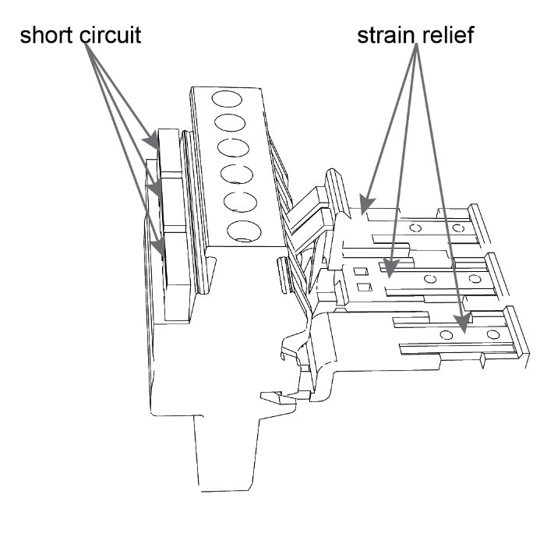

Figure : X12 terminals; with closed short circuit

Table : External interface terminals X12

|  |  |
| --- | --- |
| Terminal No | Description |
| X12:1 | S1 (k), Current transformer U (L1) |
| X12:2 | S2 (l), Current transformer U (L1) |
| X12:3 | S1 (k), Current transformer V (L2) |
| X12:4 | S2 (l), Current transformer V (L2) |
| X12:5 | S1 (k), Current transformer W (L3) |
| X12:6 | S2 (l), Current transformer W (L3) |

#### Selection of current transformers

The current transformers should fulfill the following specification:

Table : Current transformer (CT) specification

|  |  |
| --- | --- |
| Current transformer specification | |
| Class | 1.0 or better |
| Primary ratio | Exceeding the maximum load current including harmonics, reactive power, and transients |
| Secondary ratio | 5 A |
| ADF total CT burden | 0.193 VA |
| Symmetry | Three identical CTs must be used; ADF P100N does not require a CT on the neutral wire. |

Note that the size of the CT is critical to the performance of the system when operating in current control. Using a very large CT in relation to the total load size will result in poor resolution and hence poor results.

|  |  |
| --- | --- |
| ⚠ | **ATTENTION:** Current Transformers with 5 A secondary must be used. CTs with 1 A secondary will give to low measurement resolution. |

#### Recommended current transformer cable size

The recommended cable size used for connection of the current transformers is dependent of the output power of the current transformers and total length of the cables. A calculation of burden must be performed to guarantee that the burden of the CT is not exceeded. Table 18 shows the need required burden in relation to the cable size and length for some examples.

Table : Burden as function of cable size and length

|  |  |  |  |  |  |  |  |
| --- | --- | --- | --- | --- | --- | --- | --- |
|  | 5 m | 10 m | 20 m | 30 m | 50 m | 100 m | 160 m |
| **0.5 mm²** | 4.4 VA | 8.6 VA | 17.0 VA | 25.4 VA | 42.2 VA | 84.2 VA | 134.6 VA |
| **0.8 mm²** | 3.0 VA | 5.8 VA | 11.4 VA | 17.0 VA | 28.2 VA | 56.2 VA | 89.8 VA |
| **1.0 mm²** | 2.3 VA | 4.4 VA | 8.6 VA | 12.8 VA | 21.2 VA | 42.2 VA | 67.4 VA |
| **1.5 mm²** | 1.6 VA | 3.0 VA | 5.8 VA | 8.6 VA | 14.2 VA | 28.2 VA | 45.0 VA |
| **2.5 mm²** | 1.1 VA | 1.9 VA | 3.6 VA | 5.3 VA | 8.6 VA | 17.0 VA | 27.1 VA |
| **4.0 mm²** | 0.8 VA | 1.3 VA | 2.3 VA | 3.4 VA | 5.5 VA | 10.7 VA | 17.0 VA |
| **6.0 mm²** | 0.6 VA | 0.9 VA | 1.6 VA | 2.3 VA | 3.7 VA | 7.2 VA | 11.4 VA |

Table : ADF CT connection data

|  |  |
| --- | --- |
| ADF CT connection data | |
| Conductor cross section solid min. | 0.14 mm2 / AWG 26 |
| Conductor cross section solid max. | 6 mm2 / AWG 10 |
| Conductor cross section stranded min. | 0.14 mm2 / AWG 26 |
| Conductor cross section stranded max. | 6 mm2 / AWG 10 |

#### Location of current transformers

The location of the current transformers is critical to the function of the Active Filter. The following guidelines should be observed for proper operation:

Closed loop control is preferred. This means that the CTs monitor the load current and the Active Filter current. However, open loop control is also possible – meaning that the CTs are placed downstream to the mains connection of the Active Filter unit.

Beside the current control in, in open and closed loop, the ADF systems also support the optional Sensorless Control.

|  |  |
| --- | --- |
| Figure : Current Transformer placement diagram – closed loop | Figure : Current Transformer placement diagram – open loop |
| Figure : No current transformer in Sensorless Control | |

|  |  |
| --- | --- |
| ⚠ | **ATTENTION:** Never open the circuit of a connected current transformer. During all connection work, short circuit the secondary of the current transformers.  Failure to short circuit the current transformers may cause dangerous voltages, arcs and destruction of the current transformers. When connection is complete, the short circuit must be removed. |

#### Connection and wiring of current transformers

* The S1 (k) terminal of each CT must be oriented to the supply side. The S2 (l) of each CT must be oriented toward the load side.
* The CTs must be grouped properly phase wise with the corresponding mains connection. This means that the connected to phase 1 (U) on X12 must monitor the current corresponding to phase L1 (U) of the network line connection.
* The phases must be connected in proper rotation. V must lag U, W must lag V and U must lag W.
* Either S1 (k) or S2 (l) must be individually connected to PE (Protective Earth). The connection must be performed identically for each CT.
* The connection is made to terminal block X12:1 through X12:6.
* When using the Active Filter in conjunction with a passive filter, special requirements apply. See “Appendix B Compatibility with passive compensation” for further information.

The wiring should be connected according to Table 21.

Table : CT connection table

|  |  |  |
| --- | --- | --- |
| Phase | Current transformer | Terminal block |
| U / Phase L1 | S1 (k) | X12:1 |
| S2 (l) | X12:2 |
| V / Phase L2 | S1 (k) | X12:3 |
| S2 (l) | X12:4 |
| W / Phase L3 | S1 (k) | X12:5 |
| S2 (l) | X12:6 |

In Figure 17 and Figure 18, the correct connection of mains power and current transformers with correct grounding is illustrated. The example shows close loop operation on an ADF P100 and ADF P100N.

|  |  |
| --- | --- |
| Figure : ADF P100 Current Transformer connection diagram – closed loop | Figure : ADF P100N Current Transformer connection diagram – closed loop |

#### Connection of current transformers with paralleled systems

Figure 19 illustrates correct connection of two paralleled Active Filters, again in closed loop operation with correct grounding:

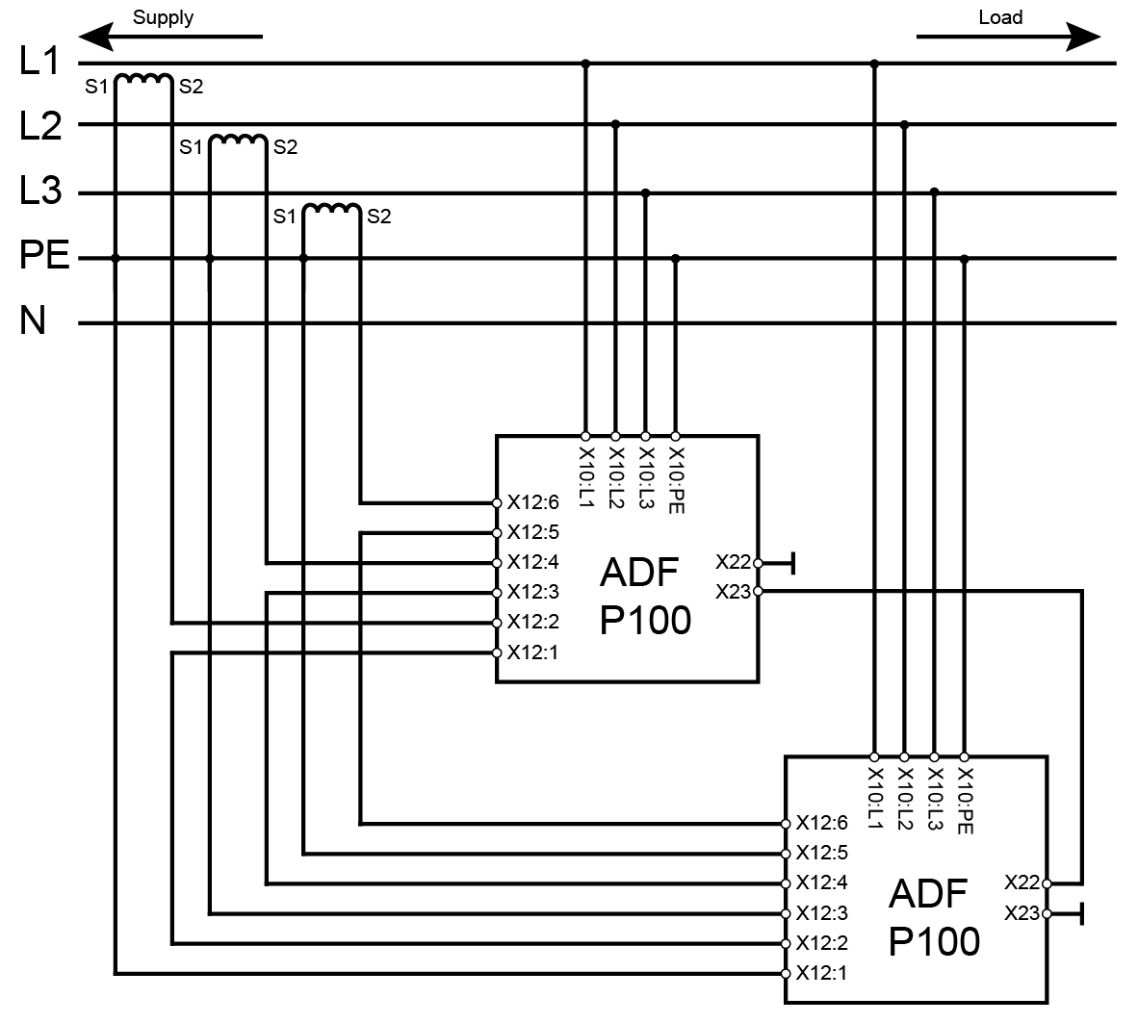

Figure : Current Transformer connection diagram – paralleled units

#### Use of summation current transformers

Summation current transformers can be used in certain configurations. Some examples of usable scenarios:

* When compensating loads, in closed loop operation, fed by two or more transformers which are paralleled. The secondary sides must then be added to the current input of the ADF P100 using a summation current transformer.
* When compensating loads, in open loop configuration, where the main CTs must be placed on two or more outgoing groups.

In all cases, when using summation CT’s, the ratio must be selected so that full signal corresponds to 5 A on the secondary of the summation transformer going into the X12 terminal block.

### Local area network (X21)

The RJ45 LAN socket allows connection to the SCC2 control computer and is used for configuration and monitoring of the ADF via a standard Ethernet network or directly from a PC. Optional this RJ45 also supports Modbus. Please see the User Manual for more information on how to connect to the ADF.

For fixed installations, Comsys suggests using a shielded Ethernet cable.

### Multi-master bus (X22 & X23; optional)

The RJ45 MM-bus sockets are used for inter-ADF communication for example when several ADFs are operated in parallel in Multi-master operation. ADFs are connected as a daisy-chain with termination plugs in each end of the chain like shown in figure below. X22 and X23 are freely interchangeable.

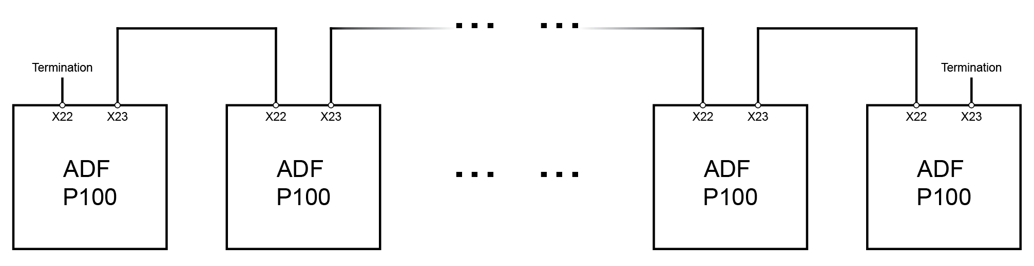

Figure : Example setup for Multi-master operation

A “FTP category 5” or better Network cable can be used to connect ADF’s to each other. The maximum length of the entire cable is 100 m / 328 ft.

|  |  |
| --- | --- |
| ⚠ | **ATTENTION:** The electrical interface of the RJ45 MM- bus connectors is different from that of the LAN. Be sure to only connect equipment approved by Comsys on this bus or equipment damage may result. |

# Maintenance

This chapter is divided into two parts; firstly, all systems maintenance which is identical to all variants of the ADF P100 is covered.

The ADF P100 is fully serviceable from the front, bottom and top after removing all covers. All internal parts can be changed without dismounting the entire unit if for example mounted on a wall.

Every 6 months, a routine inspection is performed. In most cases, no components are exchanged during biannual inspection.

|  |  |
| --- | --- |
| NOTE | Warranty is void if maintenance is not performed according to schedule. |

|  |  |
| --- | --- |
| ⚠ | **ATTENTION:** All maintenance must be performed by trained and qualified personnel.  Make sure no voltage is present in main circuit, auxiliary power system, AC voltage measurement circuits and power capacitors.  Follow the guidelines for preparing the ADF P100 for maintenance before attempting to perform any work in this section.  ADF P100 consists of electronics sensitive to electrostatic voltage.  When tightening electrical or mechanical connections be sure to apply the correct torque. |

Before attempting any maintenance, the ADF P100 must be shut down by disconnecting the mains in the customer switchgear or similar, followed by taking appropriate safety measures.

## Biannual inspection

The following items are included in the maintenance procedure:

* Visual inspection
* Cleaning
* Cooling system
* Cover inspection
* Electrical connections

### Removal of covers

To be able to perform inspections the covers must be removed.

Start by remove the cover of the Control Module (CM), see section 2.2.2. Do this by loosen the two screws partly. Pull the cover downwards and remove it.

Remove the small white cover mounted on the top by losing the screws and pull cover down. Make sure to disconnect the HMI and PIB cable.

Remove the main cover by loosen the mounting screws on the top and remove the screws on the bottom, then lift it off.

### Visual inspection

The cover must be removed. A visual inspection must be performed of all the system. Check for any of the following items:

* Dust
* Condensation
* Abnormal smell, discoloration, soot or swelling of components
* Cracks in plastic covers
* Inspect DC capacitors for signs of overheating; be aware of swollen capacitors and signs of overheating. Such capacitors must be replaced.
* Inspect line filter AC capacitors, check for signs of damage.
* Inspect internal contactors; check for sign of damage such as soot or other discolor.
* Inspect internal cables for signs of insulation wear due to poor routing.

Pay particular attention to presence of conductive dust.

### Cleaning

All dust must be removed. The best way of doing this is to use pressurized air (from a compressor system).

|  |  |
| --- | --- |
| ⚠ | ATTENTION: The equipment is sensitive to ESD. Avoid cleaning the system with any method which may cause build-up of ESD; such as vacuum cleaning, using cloths, etc. |

Dust build-up may cause unreliability and component failure in the worst case.

### Electrical connection

Visually inspect all electrical connections. Check for signs of heated cable terminations and damaged insulation.

Check the torque on mains connections and PE.

### Change and inspection of internal fuse

Inspect the auxiliary fuses (F501) located in the Computer Module (CM).

### Cooling system

The ADF P100 has one main fan and the ADF P100N additionally an auxiliary fan. The main fan in the bottom with air outlet on the top of the unit located at one quarter from the bottom and the auxiliary fan on the top of the ADF P100N cabinet.

After restarting the unit; check that no noise indicating fan wear is audible. Also check that the air flow is strong by putting the hand over the unit.

# Appendix A Technical Specifications

## A.1 Technical Data – ADF P100

Table : Technical specifications ADF P100

|  |  |  |  |  |
| --- | --- | --- | --- | --- |
| Characteristics | | | | |
| Model | ADF P100-70/480 | ADF P100-100/480 | ADF P100-130/480 | ADF P100-90/690 |
| Rated power * | 49 / 59 kVA | 70 / 84 kVA | 91 / 109 kVA | 94 /108 kVA |
| Compensation current capacity at 50/60 Hz | 70 ARMS | 100 ARMS | 130 ARMS | 90 ARMS |
| System voltage (± 10%) | 480 V (208 – 480 V) | | | 690 V (480 – 690 V) |
| Nominal frequency | 50/60 Hz ± 5 % | | | |
| Number of phases | 3 phase 3 wire | | | |
| Connection type | 3 phase without neutral (TN, TT, IT**) | | | |
| Harmonic current compensated | individual compensation up to 49th order | | | |
| Rate of harmonic reduction | better than 98 % | | | |
| Current compensation of cos φ | up to 1.0 | | | |
| Expandability | up to 15 ADF P100 units can be used in parallel | | | |
| Response time | < 1 ms | | | |
| Power dissipation | < 1500 W | < 2235 W | < 2970 W | < 2969 W |
| Maximum air flow requirement | 600 m3/h | | | |
| Noise level | < 70 dB(A) | | | |
| Environment | 0 to 95 % RH non-condensing, max altitude 1000 m without derating | | | |
| Operating temperature | 0 to 50 °C, up to 40 °C without derating | | | |
| Dimensions | 230 x 1790 x 470 mm (W x H x D) | | | |
| Weight | 145 kg | | | 155 kg |
| Enclosure color | RAL 7035 (light grey) RAL 5017 (traffic blue) | | | |
| Protection class | IP20, IP21** according to IEC 529, other ratings upon request | | | |
| Environmental conditions | chemical 3C2, mechanical 3S2 | | | |
| Electromagnetic compatibility | EN55011, Class B | | | |
| Certificates | CE, ABS, DNV GL | | | |
| * Compensation power at 400 V / 480 V (600 V / 690 V) nominal voltage | | | | |
| ** Option | | | | |

## A.2 Technical Data – ADF P100N

Table : Technical specifications ADF P100N

|  |  |
| --- | --- |
| Characteristics | |
| Model | ADF P100N-100/415 |
| Rated power * | 70 kVA |
| Compensation current capacity at 50/60 Hz | 100 ARMS / 300 ARMS (Neutral)*** |
| System voltage (± 10%) | 208 – 415 V |
| Nominal frequency | 50/60 Hz ± 5 % |
| Number of phases | 3 phase 4 wire |
| Connection type | 3 phase with neutral (TN, TT) |
| Harmonic current compensated | individual compensation up to 49th order; 19th order in neutral |
| Rate of harmonic reduction | better than 98 % |
| Current compensation of cos φ | up to 1.0 |
| Expandability | up to 15 ADF P100N units can be used in parallel |
| Response time | < 1 ms |
| Power dissipation | < 2235 W |
| Maximum air flow requirement | 600 m3/h |
| Noise level | < 70 dB(A) |
| Environment | 0 to 95 % RH non-condensing, max altitude 1000 m without derating |
| Operating temperature | 0 to 50 °C, up to 40 °C without derating |
| Dimensions | 230 x 1790 x 470 mm (W x H x D) |
| Weight | 170 kg |
| Enclosure color | RAL 7035 (light grey) RAL 5017 (traffic blue) |
| Protection class | IP20, IP21** according to IEC 529, other ratings upon request |
| Environmental conditions | chemical 3C2, mechanical 3S2 |
| Electromagnetic compatibility | EN55011, Class B |
| Certificates | CE |
| * Compensation power at 400 V nominal voltage | |
| ** Option | |
| *** Derating applies above 415 V | |

## A.3 Technical Data – ADF P100v2B

Table : Technical specifications ADF P100v2B

|  |  |  |  |  |  |
| --- | --- | --- | --- | --- | --- |
| Characteristics | | | | | |
| Model | ADF P100v2B-50/480 | ADF P100v2B-75/480 | ADF P100v2B-90/480 | ADF P100v2B-120/480 | ADF P100v2B-150/480 |
| Rated power * | 35 / 42 kVA | 52 / 62 kVA | 62 / 75 kVA | 83 / 100 kVA | 104 / 125 kVA |
| Compensation current capacity at 50/60 Hz | 50 ARMS | 75 ARMS | 90 ARMS | 120 ARMS | 150 ARMS |
| System voltage (± 10%) | 480 V (208 – 480 V) | | | | |
| Nominal frequency | 50/60 Hz ± 5 % | | | | |
| Number of phases | 3 phase 3 wire | | | | |
| Connection type | 3 phase without neutral (TN, TT, IT**) | | | | |
| Harmonic current compensated | individual compensation up to 49th order | | | | |
| Rate of harmonic reduction | better than 98 % | | | | |
| Current compensation of cos φ | up to 1.0 | | | | |
| Expandability | up to 15 ADF P100 units can be used in parallel | | | | |
| Response time | < 1 ms | | | | |
| Power dissipation | < 1600 W | < 2535 W | < 3180 W | < 3155 W | < 3225 W |
| Maximum air flow requirement | 600 m3/h | | | | |
| Noise level | < 70 dB(A) | | | | |
| Environment | 0 to 95 % RH non-condensing, max altitude 1000 m without derating | | | | |
| Operating temperature | 0 to 50 °C, up to 40 °C without derating | | | | |
| Dimensions | 230 x 1790 x 470 mm (W x H x D) | | | | |
| Weight | 91 kg | 91 kg | 91 kg | 105 kg | 116 kg |
| Enclosure color | RAL 7035 (light grey) RAL 5017 (traffic blue) | | | | |
| Protection class | IP20, IP21** according to IEC 529, other ratings upon request | | | | |
| Environmental conditions | chemical 3C2, mechanical 3S2 | | | | |
| Electromagnetic compatibility | EN55011, Class B | | | | |
| Certificates | CE, ABS, DNV GL | | | | |
| * Compensation power at 400 V / 480 V (600 V / 690 V) nominal voltage | | | | | |
| ** Option | | | | | |

## A.4 Dimensions – ADF P100

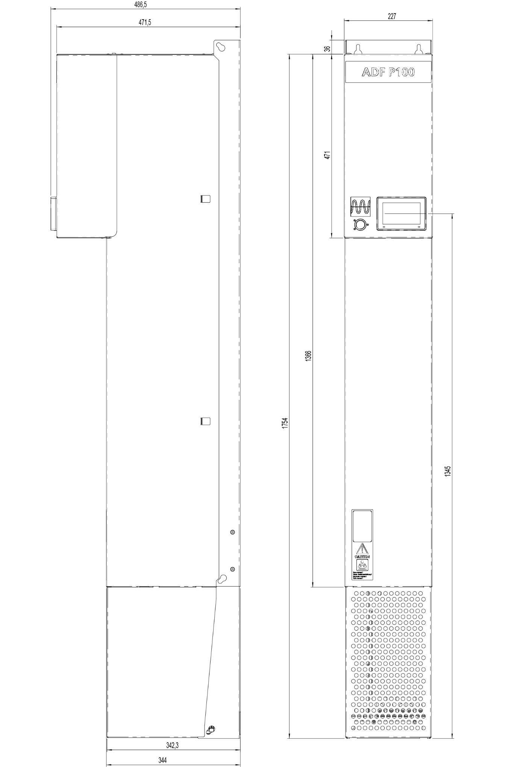

Figure : Dimensions ADF P100 (in mm)

## A.5 Dimensioning – ADF P100N

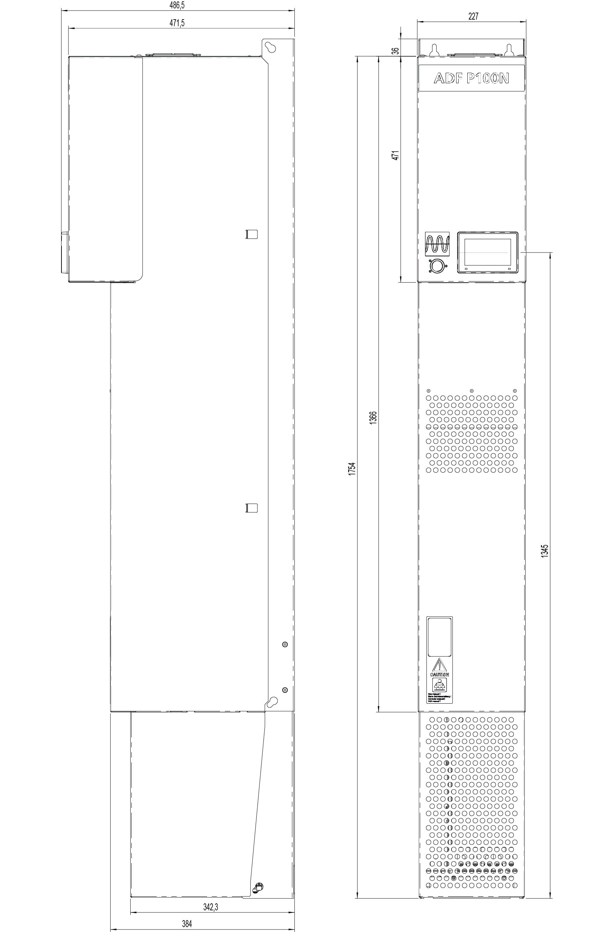

Figure : Dimensions ADF P100N (in mm)

## A.6 Dimensions – ADF P100 (IP21)

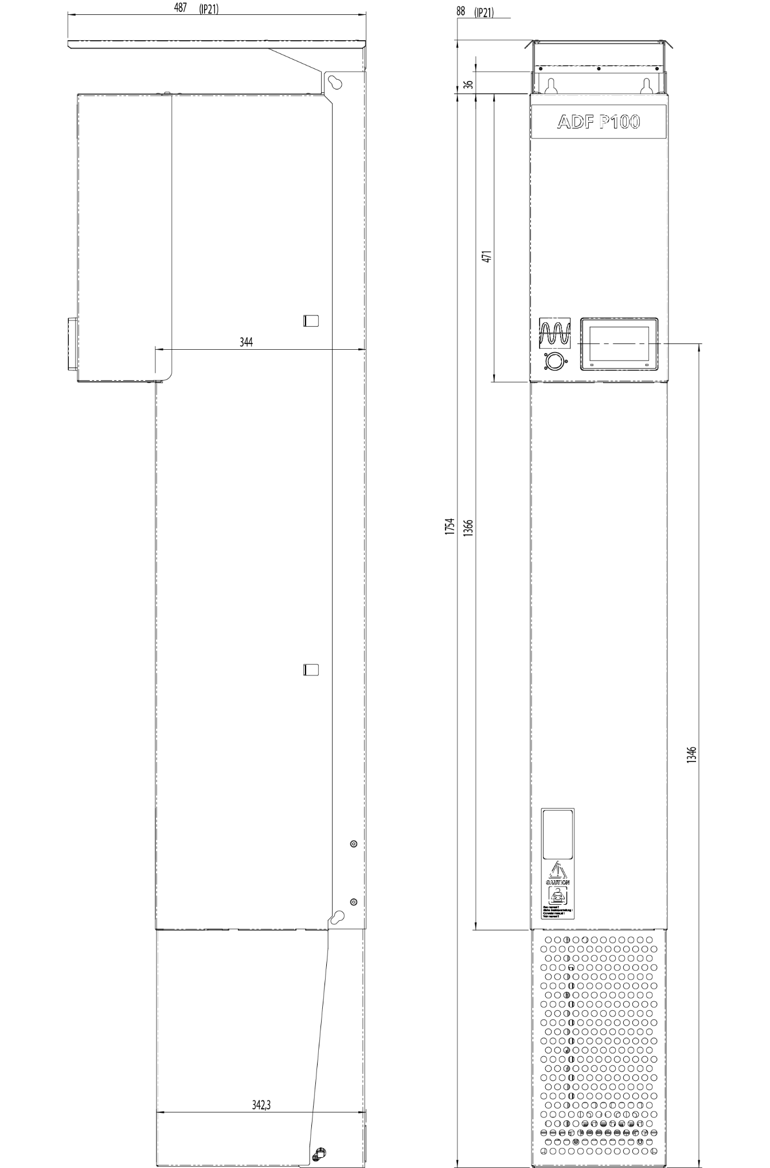

Figure : Dimensions ADF P100 IP21 (in mm)

## A.7 Dimensions – ADF P100N (IP21)

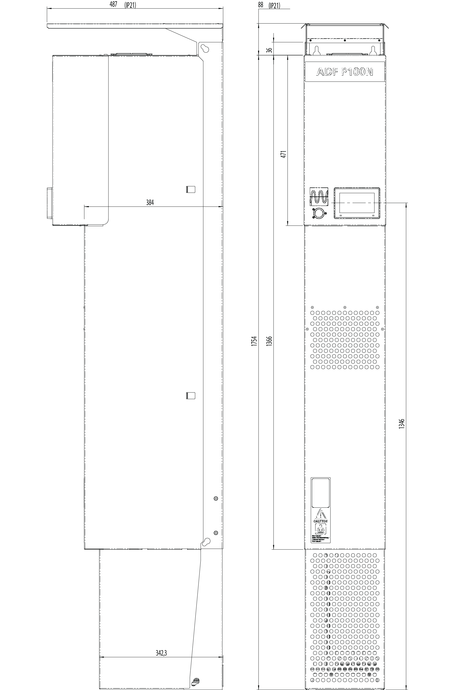

Figure : Dimensions ADF P100N IP21 (in mm)

# Appendix B Compatibility with passive compensation

Capacitor banks are often used in various configurations to lower the reactive power in an installation. It is a recognized problem that the impedance of capacitors falls with rising frequency and hence capacitors act as a sink for harmonics.

It is **not recommended** to use Active Filter units in conjunction with direct connected passive compensation without series reactors. Detuned capacitor banks are easier to integrate with Active Filters.

In all cases, the capacitor bank should be connected prior to the current measurement used for the Active Filter, as illustrated in Figure 25 below. When using the Active Filter in conjunction with detuned capacitor banks, it is strongly recommended to configure the Active Filter for closed loop current measurement.

The passive compensation **must** be placed upstream to the Active Filter.

Note that the Active Filter unit’s current transformers (CTs) are placed prior to the load, but after the passive compensation, viewing from the supply side.

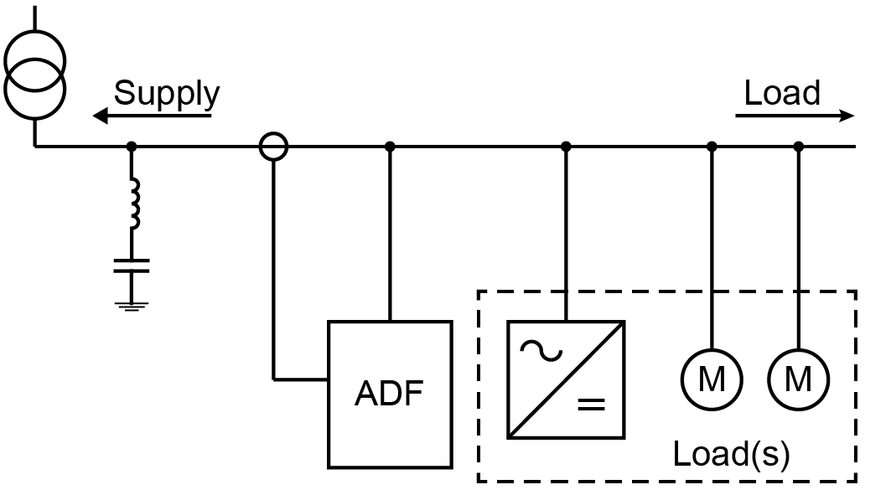

Figure : Connection of an Active Filter unit, passive compensation, and location of CTs.

|  |  |
| --- | --- |
| ⚠ | **ATTENTION:** Failure to observe the orientation guidelines above will significantly shorten the lifetime of the passive compensation, lower the efficiency of both the Active Filter unit and the passive compensation, and may cause unpredictable results. |

# Appendix C Harmonics derating

The current rating of Active Filter units is specified at the system frequency (50 or 60 Hz). This is sufficient in all normal applications since higher harmonics are lower in amplitude in most cases. For special applications, requiring very high harmonic current in high harmonic orders, special care must be taken. A rating of 100 ARMS does not imply that the unit can output 100 ARMS @ 1250 Hz (25th harmonic in a 50 Hz system).

The following guidelines are useful for determining the maximum allowable higher harmonic current during normal operation of COMSYS Active Filters.

## C.1 Single harmonic maximum current

The following guidelines are established for maximum continuous current only when the unit is running at maximum rated ambient temperature. During dynamic operation with lower ambient temperature than the maximally allowed, burst currents may be significantly higher. In the same fashion, in continuous operation at temperatures higher than the maximum allowed, the unit automatically derates the output to not shorten component lifetime.

The following table can be used to determine the maximum individual current, as percentage of the rated maximum compensation current:

Table : Maximum current output on single harmonics

|  |  |  |  |  |  |  |  |
| --- | --- | --- | --- | --- | --- | --- | --- |
| h | Output (%) |  | h | Output (%) |  | h | Output (%) |
| 1 | 100 % |  | 19 | 60 % |  | 37 | 40 % |
| 3 | 100 % |  | 21 | 55 % |  | 39 | 35 % |
| 5 | 100 % |  | 23 | 55 % |  | 41 | 35 % |
| 7 | 100 % |  | 25 | 50 % |  | 43 | 35 % |
| 9 | 90 % |  | 27 | 45 % |  | 45 | 30 % |
| 11 | 80 % |  | 29 | 45 % |  | 47 | 30 % |
| 13 | 75 % |  | 31 | 40 % |  | 49 | 30 % |
| 15 | 70 % |  | 33 | 40 % |  |  |  |
| 17 | 65 % |  | 35 | 40 % |  |  |  |

In the given table, h is the harmonic order. For a unit rated at 100 ARMS, the maximum current of the 23rd harmonic is consequently 55 ARMS.

## C.2 Determining the thermal limit

Given that each harmonic current is within the limits outlined above, the total limit of the system as a whole can be determined as follows. First, calculate the individual contribution of each harmonic:

Ih,contrib = Ih / OUT(%,h)

where h is the harmonic order and Ih is the corresponding current. Finally, add the individual harmonic contributions as a root sum:

Itotal = SQRT(I3,contrib2 + I5,contrib2 + … + I49,contrib2 + Ireactive,contrib2)

The answer is the amount of unit current rating needed to be able to compensate the load. Eventual reactive current can be added in the formula above as Ireactive,contrib.

**Example:**

A load needs 85 ARMS at the 5th harmonic and 50 ARMS at 7th harmonic. The individual contributions are I5,contrib = 85 ARMS / 100 % = 85 ARMS for fifth harmonic and I7,contrib = 50 ARMS / 100 % = 50 ARMS for the seventh harmonic. The RMS sum of the two components are 98.6 ARMS. Thus, a 100 A unit will be sufficient to compensate the load. Adding an 11th harmonic of 35 ARMS adds an equivalent contribution of 43.8 ARMS yielding a total needed capacity of 107.8 ARMS which will not work in an 100 A unit in continuous operation at maximum allowed ambient temperature.

## C.3 Summary

In most cases the above guidelines are sufficient to establish the needed Active Filter size to fully compensate the desired harmonics. Since the exact calculations are complex the guidelines established in this document can be considered safe limits.

For detailed calculations or custom solutions, please contact your Comsys ADF supplier.

The formulas and guidelines are valid for all ADF P100 Active Filters systems up to the 49th harmonic.

# Appendix D Power derating

## D.1 Altitude derating

The current rating of the ADF units is specified up to an altitude of 1000 m / 3281 ft.. At higher altitudes the current rating will be reduced.

When using an ADF P100 on altitudes above 1000 m / 3281 ft, the maximum output will be derated according to the following:

Altitude derating [%] = (h – 1000) / 100 (h = height in meter)

Altitude derating [%] = (h – 3281) / 328 (h = height in feet)

For example, at an altitude of 1500 m, the derating will be 5 %. In this case the compensation capacity of an ADF P100-130/480 will be derated from130 ARMS to 123 ARMS.

## D.2 Overtemperature derating

The ADF P100 loses 1.5 % of output current per degree Celsius over 40 °C. At 50 °C, the output current is reduced 15 %.

The system will trip at 55 °C. Temperature derating is automatic and only uses sensors present in the ADF P100 system.

|  |  |  |
| --- | --- | --- |
|  | **Comsys AB** Fältspatvägen 4 SE-224 78 LUND Sweden  +46 10 209 68 00 [info@comsys.se](mailto:info@comsys.se) [adfpowertuning.com](https://adfpowertuning.com/) | **Partner:** |
| Comsys AB does not assume any responsibility for use of any product or method described and also reserves the right to make changes at any time without prior notice in order to improve design and supply the best possible products. | | |