Sinexcel SVG Application for MV/HV Systems
There are applications where SVG must be applied to MV/HV system. Most of them are interconnected power generation projects, such as photovoltaic power, wind power and tidal power. For projects with small capacity ( less than 1 MW ), using low voltage SVG with step-up transformers is more cost-effective than MV/HV SVG.
There are 2 types of step-up transformer: Yyn0 and Dyn11. No matter which kind of transformer is used, the capacity should always be more than 1.2 times of SVG system capacity.
1.YYN0
Using Yyn0 transformer would be the first choice because there's no phase shifting in output voltage and current.
When CT installed at load side, connection should be like this:
​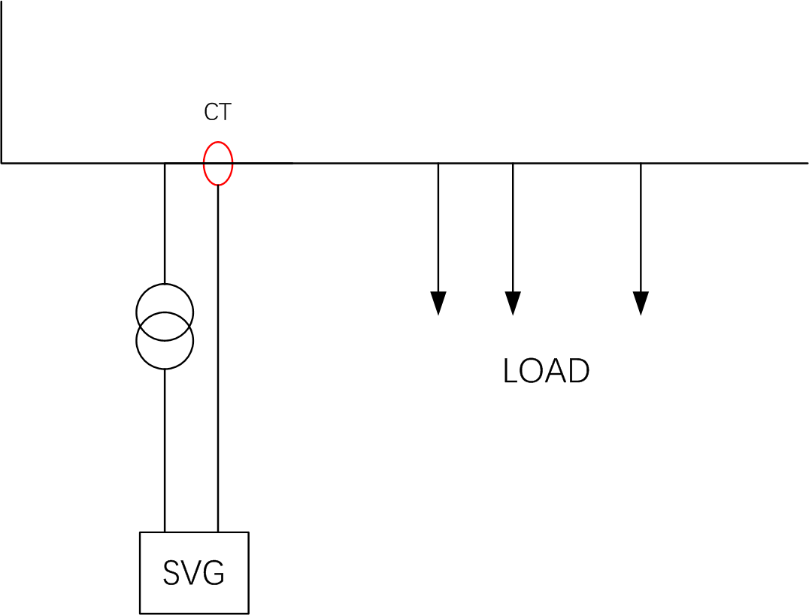​
Relative monitor setting parameters and corresponding values are:
PT Ratio: the transformer ratio
Transformer connection: YYN
1st Angle Biasing:0
​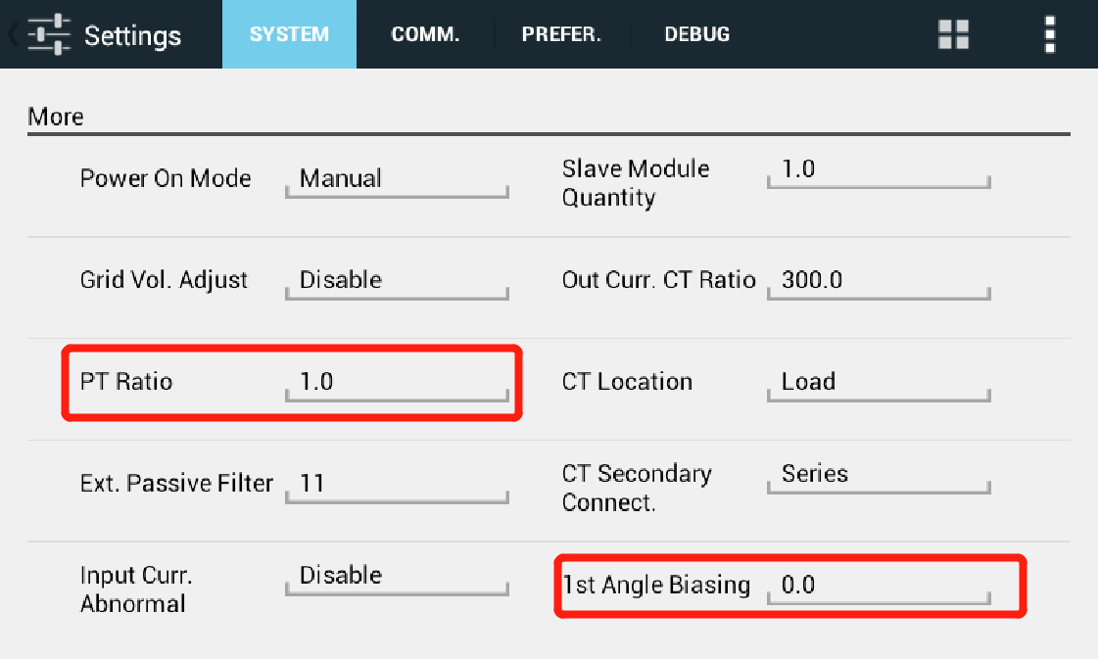​​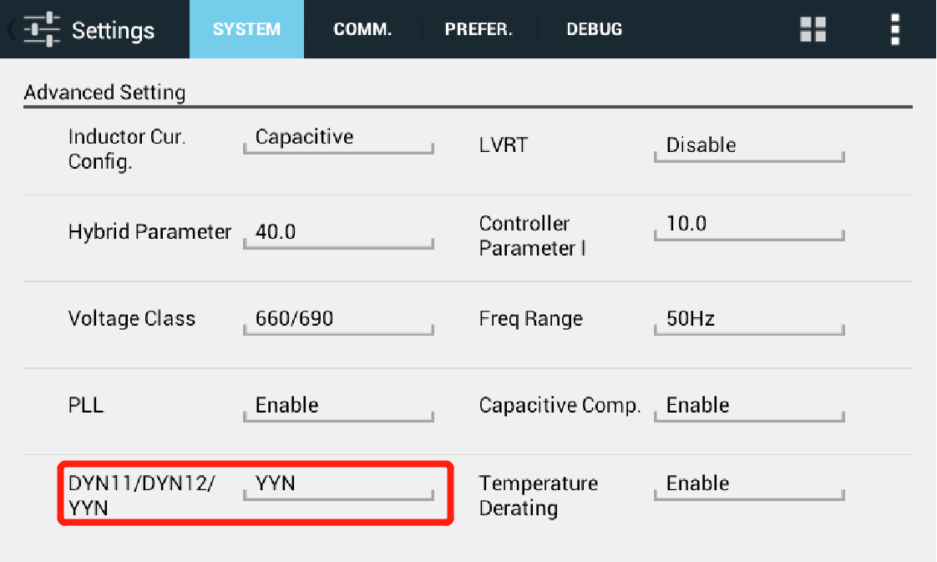​
If it's inconvenient to install CT at load side, following equivalent load side CT installation can be applied.
​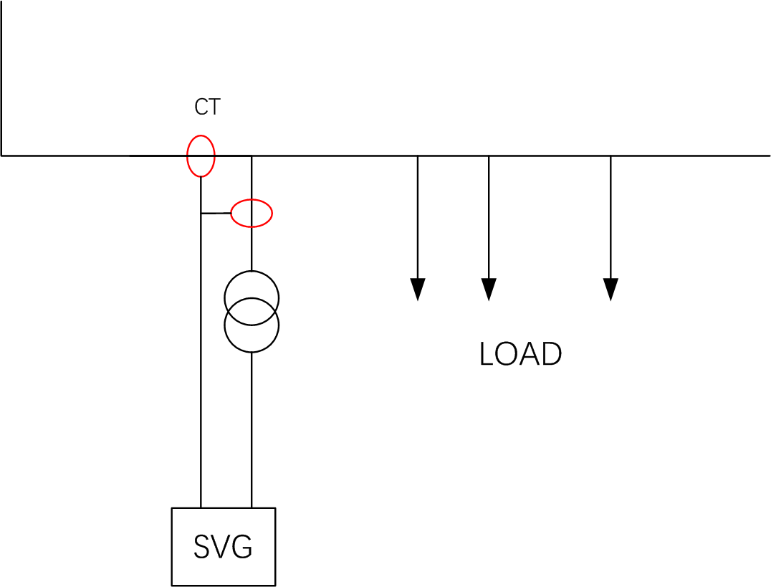​

2.DYN11
When using DYN11 transformer, there's a 30 degree phase shifting in output voltage and current. So the parameter "1st Angle Biasing" should be "-30". Other settings and installation are the same with those of YYN0 transformer.

3.CT transfer board
When there are over one set of CT used in the system and they have different ratio, a CT transfer board can be applied to unify CT signal feeding to SVG. The CT transfer board is actually a small transformer and the ratio should be original CT ratio over expected CT ratio.

