|  |
| --- |
|  |

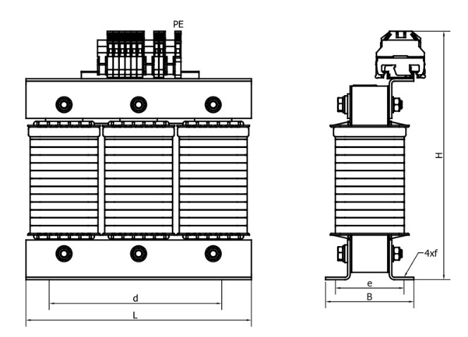

Wyk. A Wyk. B

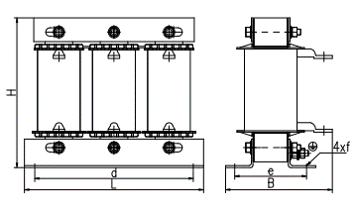

Wyk. C

|  |  |  |  |  |  |  |  |  |  |  |
| --- | --- | --- | --- | --- | --- | --- | --- | --- | --- | --- |
| Parametry techniczne: | | | Wymiary | | | | | | Masa |  |
| Typ | Prąd | Induk.  [mH] | L  [mm] | B  [mm] | H  [mm] | d  [mm] | e  [mm] | f  [mm] | [kg] | wyk |
| INDU 3-8-400 | 8,0 | 0,82 | 155 | 75 | 140 | 100 | 50 | 8x12 | 2,6 | A |
| INDU 3-11-400 | 11,0 | 0,6 | 155 | 75 | 140 | 100 | 50 | 8x12 | 3 | A |
| INDU 3-15-400 | 15,0 | 0,44 | 155 | 75 | 140 | 100 | 50 | 8x12 | 3,3 | A |
| INDU 3-21-400 | 21,0 | 0,31 | 155 | 80 | 130 | 100 | 55 | 8x12 | 3,6 | C |
| INDU 3-28-400 | 28,0 | 0,23 | 155 | 80 | 130 | 100 | 55 | 8x12 | 3,9 | C |
| INDU 3-35-400 | 35,0 | 0,19 | 155 | 90 | 130 | 100 | 65 | 8x12 | 4,1 | C |
| INDU 3-42-400 | 42,0 | 0,16 | 155 | 90 | 130 | 100 | 65 | 8x12 | 4,3 | C |
| INDU 3-56-400 | 56,0 | 0,11 | 190 | 115 | 155 | 170 | 56 | 8x12 | 4,5 | C |
| INDU 3-70-400 | 70,0 | 0,095 | 190 | 115 | 155 | 170 | 56 | 8x12 | 4,8 | C |
| INDU 3-85-400 | 85,0 | 0,078 | 190 | 130 | 155 | 170 | 71 | 8x12 | 7,8 | C |
| INDU 3-100-400 | 100,0 | 0,066 | 190 | 135 | 155 | 170 | 76 | 8x12 | 8,0 | C |
| INDU 3-125-400 | 125,0 | 0,056 | 190 | 145 | 155 | 170 | 86 | 8x12 | 10 | C |
| INDU 3-180-400 | 180,0 | 0,036 | 240 | 106 | 190 | 185 | 84 | 10x18 | 14,0 | **C** |
| INDU 3-200-400 | 200,0 | 0,033 | 240 | 106 | 210 | 185 | 94 | 10x18 | 15,5 | C |